**《JavaEE架构程序设计》**

**本科生课程实验报告**

|  |  |
| --- | --- |
| **题目：** | **小王音乐播放管理系统** |
| **专业：** | **软件工程** |
| **班级：** | **软件工程卓越工程师班** |
| **姓名：** | **王素婷** |
| **学号：** | **2021302111098** |

**武汉大学计算机学院**

**2024年1月1日**

**郑 重 声 明**

本人呈交的实验报告，是在指导老师的指导下，独立进行实验工作所取得的成果，所有数据、图片资料真实可靠。尽我所知，除文中已经注明引用的内容外，本实验报告不包含他人享有著作权的内容。对本实验报告做出贡献的其他个人和集体，均已在文中以明确的方式标明。本实验报告的知识产权归属于培养单位。

本人签名： 王素婷 日期： 2024年1月1日

**Abstract**

This music playback management system is developed for JavaEE course design to provide a fully functional music management and playback platform. The system includes both front and backend parts. The frontend allows users to browse song lists, information related to artists, and implement the search list and song functions. Users can also play and download the music they are interested in and modify their information. The backend allows administrators to add, delete, change and play music for singers, song lists and music.

The technology stack of this music management system includes Vue.js, Element UI, ECharts, Spring Boot, Spring MVC, MyBatis, MySQL, Redis and JWT. These technologies work together to achieve the system's front-end and back-end development, data storage and processing, user interface construction and data visualization.

With this music playback management system, users can better discover new music and artists, and administrators can manage the music system well.

**Keywords:** music management system; SpringBoot; Vue; Spring MVC

**Contents**

**1 Outlined**

1.1 Topic background………………………………………………………..…………5

1.2 Demand analysis…………………………………………………………...………6

**2 System Design and Implementation**

2.1 System architecture design…………………………………………...….…………8

2.2 System technology selection and development environment………………………8

2.3 Functional module design……………………………………………...…………10

2.3.1 UI Design…………………………………………………………….…………10

2.3.1 Database design……………………………………………………...…………19

2.4 Code implementation…………………………………………………………..…21

2.4.1 login function implementation…………………….……………………………21

2.4.2 song upload function implementation…………………………………..………30

2.4.3 search song function implementation……………………………………...……37

**3 Testing and Evaluation**

3.1 Functional test evaluation……………………………………………...…………39

**4 Summary**

4.1 Team composition and individual contributions…………………………..………52

4.2 Project problems and deficiencies……………………………………...…………52

4.3 Project outlook……………………………………………………………………52

**5 Learning Experience**

5.1 Technical experiences……………………………………………………….……54

5.2 Learning experiences………………………………………………..……………56

**1 Outlined**

**1.1 Topic background**

Music is an indispensable part of people's lives, and with the development of the Internet and digital technology, the demand for music playback platforms is growing. Users need a music management and playback platform that is functional, easy to use and has a good user experience to satisfy their needs for music enjoyment and management. Based on this background, the development of a music playback management system has become a meaningful topic for selection.

The following are some of the background considerations for this topic:

1. Growth of the music market: the music market has experienced tremendous growth with the rise of digital music and the popularity of online music platforms. Users can easily access various genres of music and discover new artists and musical works through music platforms. Therefore, developing a music playback management system is an important part of fulfilling users' needs.
2. Need for music management: It is important for music lovers and managers to manage music information and discover new songs. A well-functioning music management system can help administrators easily manage their music, provide a platform for users to discover new music, and offer personalised music recommendations and playback experience.
3. Technology Development and Application Requirements:With the rapid development of front-end and back-end technologies, there is a great potential to develop a music playback management system using a modern technology stack. By using technologies such as Vue.js, Spring Boot, etc., it is possible to build a powerful, high-performance, user-friendly music management and playback platform.

In summary, the background of the topic selection for the music playback management system is based on the consideration of the growth of the music market, the demand for music management and the development of technology. By developing such a system, it can satisfy users' needs for discovering new music and administrators' needs for convenient music management, provide convenient music browsing, searching, playing, downloading and management functions, and ensure a good user experience of the system.

**1.2 Demand analysis**

The following is a requirement analysis of the system:

**User Requirements:**

Registration: the user can register a new account to log in to change the system.

Logging out: users can log in and out of the system.

Browse song list and artist information: users can browse the song list and related artist information provided in the system in order to discover new music and artists.

Search Function: Users can search song lists and songs by keywords in order to quickly find music content of interest.

Playing and downloading music: Users can play music in the system, including operations such as pause, stop, previous and next song, in order to provide a good music playing experience, and have the option to download their favourite music files.

Modify Personal Information: Users can modify their personal information, including user name, password, avatar, etc. in order to personalise and manage their account.

**Administrator Requirements:**

Singer, Song List and Music Management: Administrator can add, delete, modify and query the singer, song list and music in the system to ensure the data integrity and accuracy of the system.

Music Playback Control: Administrator can control the music playback.

User Management: Administrator can manage user accounts, including viewing user information, deleting accounts and other operations to maintain system security and order.

Song list song management: administrator can add, delete, change and check the songs in the song list and other operations.

System data display function: you can display various data of the system in the home page of the management system, such as the number of users, the number of songs, the number of song lists, etc..

**System performance requirements:**

Friendly user interface: the system should provide an intuitive, beautiful and easy-to-use user interface to provide a good user experience.

Fast Response: The system should have the ability to respond quickly to user operations in order to reduce user waiting time.

Data security: the system should protect the personal information and account security of users and administrators, and take appropriate security measures to prevent data leakage and malicious attacks.

**Technical Requirements:**

Front-end technology: the system should use front-end technologies such as Vue.js and Element UI to realise the construction of the user interface and interactive functions.

Back-end technology: The system should use back-end technologies such as Spring Boot, Mybatis and Spring MVC to handle user requests, perform business logic processing and data storage.

Database: The system should use MySQL as the main data storage and management tool to store user information, music data, and system configuration.

Data caching: The system can use Redis and other technologies to provide data caching functions to improve system performance and response speed.

JWT technology: Generate and validate access tokens for administrator and user authentication and authorisation.

Data visualisation: The system can use technologies such as ECharts to visualise music data for administrators to make data analysis and management decisions.

**2 System Design and Implementation**

**2.1** **System architecture design**

The overall architecture adopts a typical three-layer architecture, including Presentation Layer, Business Logic Layer and Data Access Layer.

**Presentation Layer:**

Front-end framework: Use front-end frameworks such as Vue.js and Element UI to build user-friendly interfaces and achieve interaction between users and the system.

User Interface: Provide the user interface for song list browsing, searching, playing and downloading music, as well as pages for personal information management and system settings.

**Business Logic Layer:**

Front-end controller: use Spring MVC and other frameworks to process user requests and send them to the corresponding business logic processing module.

Business Logic Processing: including song list management, singer management, music management and other functional modules, processing user requests and the corresponding business logic processing.

Authentication and Certification: Implement user authentication and rights management to ensure that only authorised users can access specific functions and data.

**Data Access Layer (DAL):**

Database: Uses MySQL as the main data storage and management tool to store data such as song lists, artists, music and user information.

Object-Relational Mapping (ORM): Use frameworks such as MyBatis for mapping between objects and relational databases to achieve data persistence and access.

Caching: Use Redis and other technologies to provide data caching functions, reduce access to the database, improve system performance and response speed.

**2.2 System technology selection and development environment**

**System technology selection：**

The music management system was developed using the following technology stack:

Front-end technologies:

Vue.js: a JavaScript framework for building user interfaces.

Element UI: a set of component libraries based on Vue.js that provide rich UI components and styles.

ECharts: a powerful data visualisation library for generating charts and graphical presentations.

Back-end technologies:

Spring Boot: development framework for rapidly building Java applications.

Spring MVC: Web framework based on the Spring Framework for handling HTTP requests.

MyBatis: an excellent persistence framework for database operations and ORM mapping.

MySQL: A commonly used relational database management system for data storage and retrieval.

Redis: an in-memory database used to efficiently cache data and provide fast access.

JWT (JSON Web Token): an open standard for authentication and authorisation used to generate and validate access tokens.

The front-end of the system uses Vue.js as the main framework in conjunction with the Element UI component library for user interface construction and interaction.The ECharts library is used to generate various charts and data visualisations.

The back-end is developed using Spring Boot framework for rapid development, using Spring MVC to handle HTTP requests and build APIs.MyBatis framework is used for database operations and object-relational mapping with MySQL database for data storage and retrieval.Redis is used for caching data to improve the performance and responsiveness of the system.

For authentication and authorisation, the system uses the JWT standard to generate and validate access tokens to ensure user security and rights management.

**Development environment：**

IntelliJ IDEA: 2022

SpringBoot: 3.0.3

Mybatis: 3.0.3

MySQL: 8.0.29

Redis: 3.0.503

Vue: 2.x

JWT: 4.4.0

Java: 1.9

**2.3 Functional module design**

**2.3.1 UI design**

**front end:**

**Pages Design**

login page:

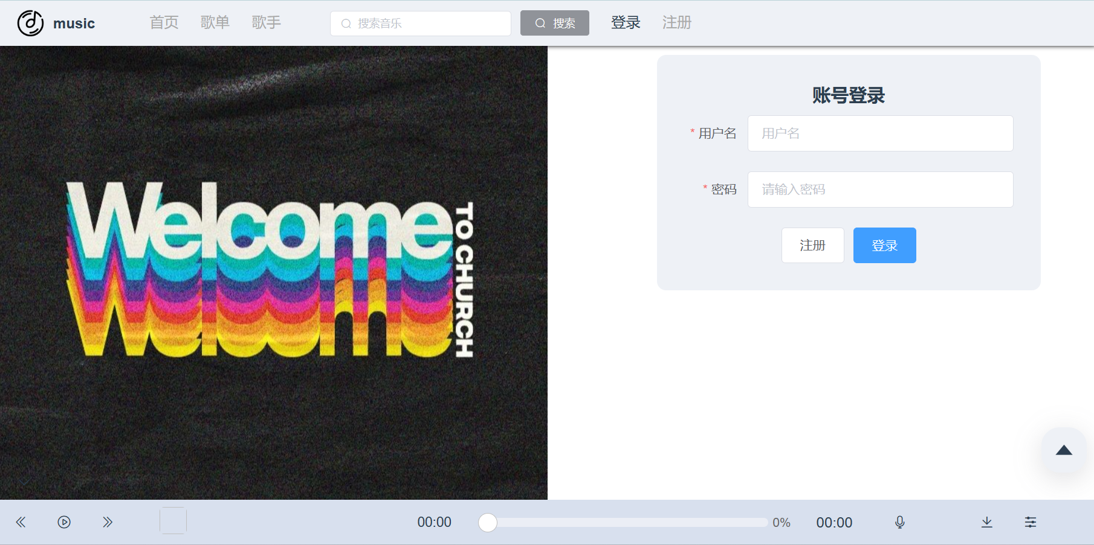

The login page includes a username and password entry box and a jump to the registration page and login button.

registration page:

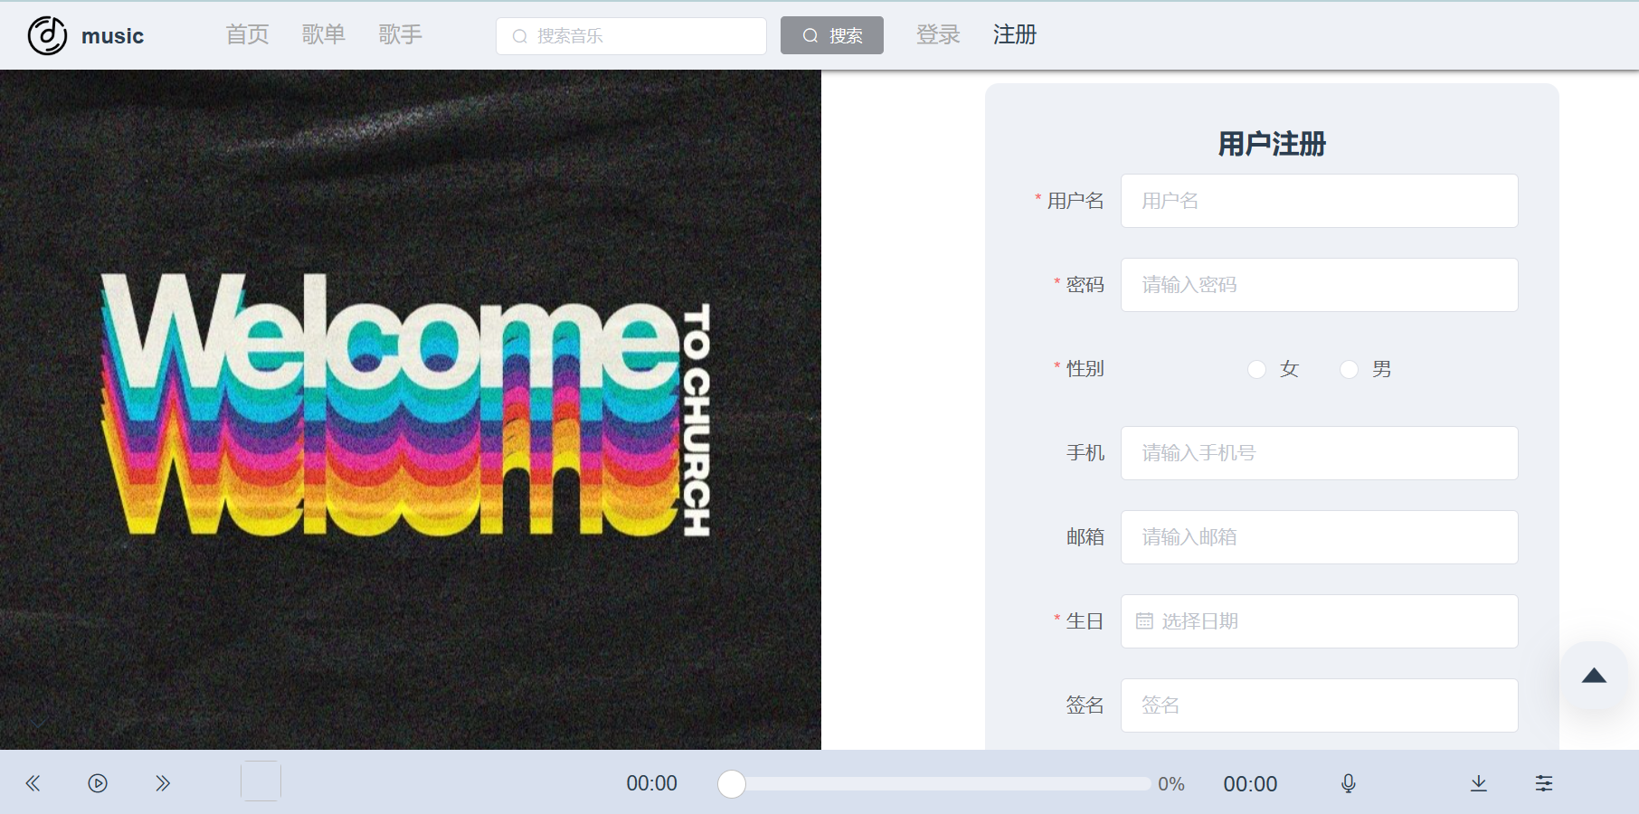

Registration includes a form with information about the user and OK and Cancel buttons.

home page:

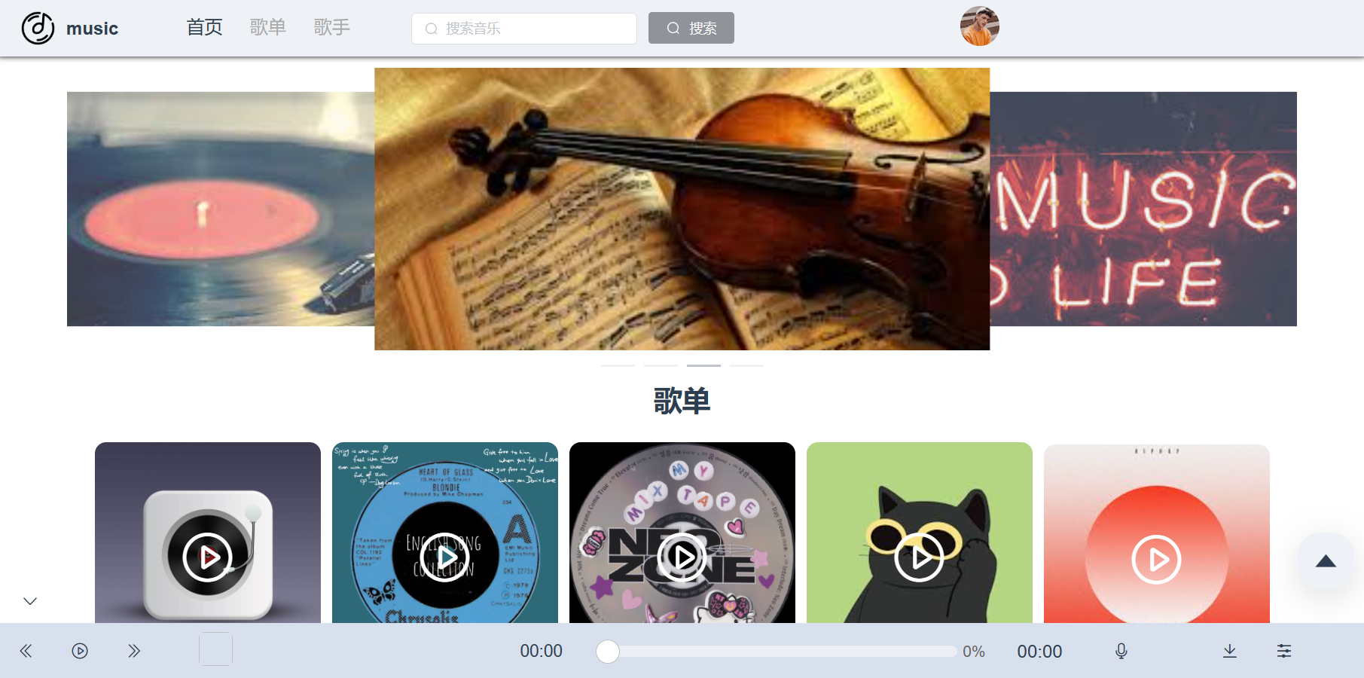

The home page includes a rotating image and a list of popular songs and artists. Clicking on a popular song and artist will redirect you to the details page.

song list detail page:

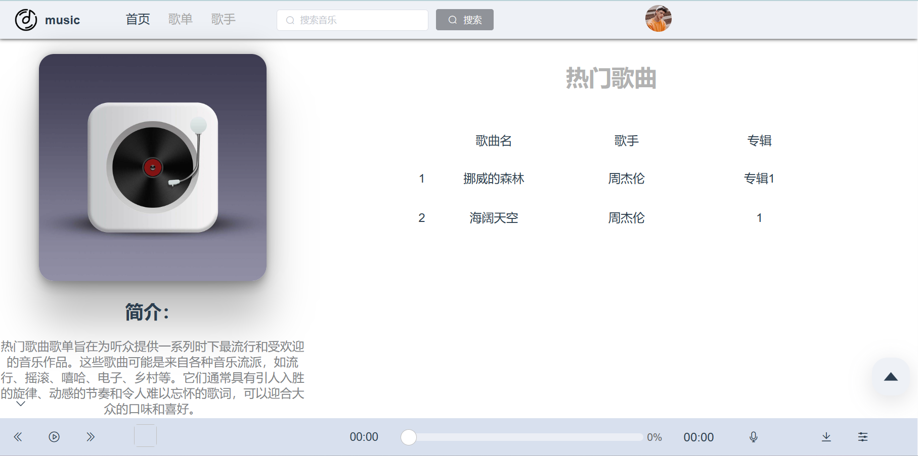

The song list details page shows the details of the song list and the songs in the list, which can be played by clicking on them.

artist details page:

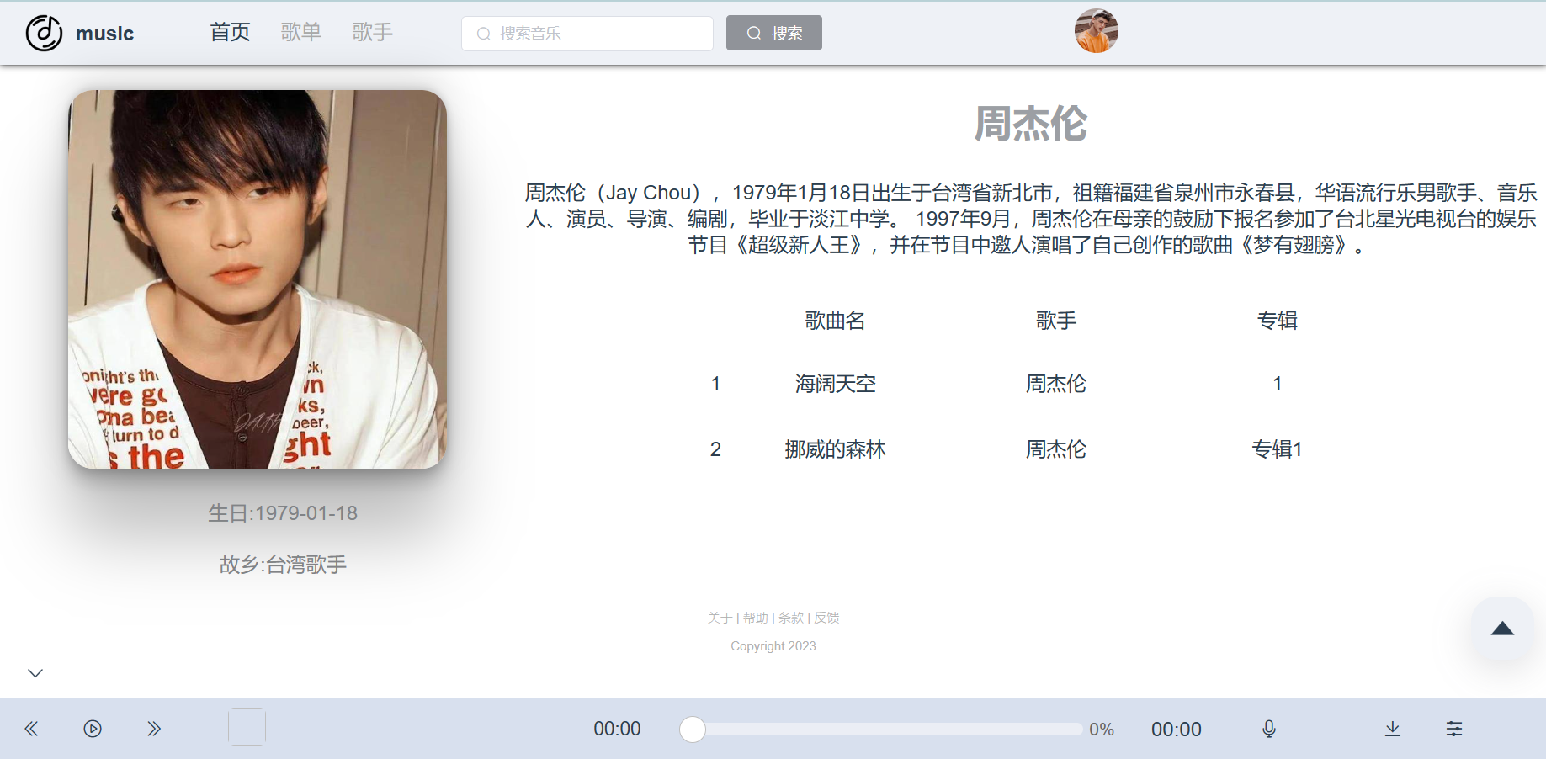

Artist details page shows the details of the artist and the songs posted by the artist, and you can play them by clicking on them.

song search page:

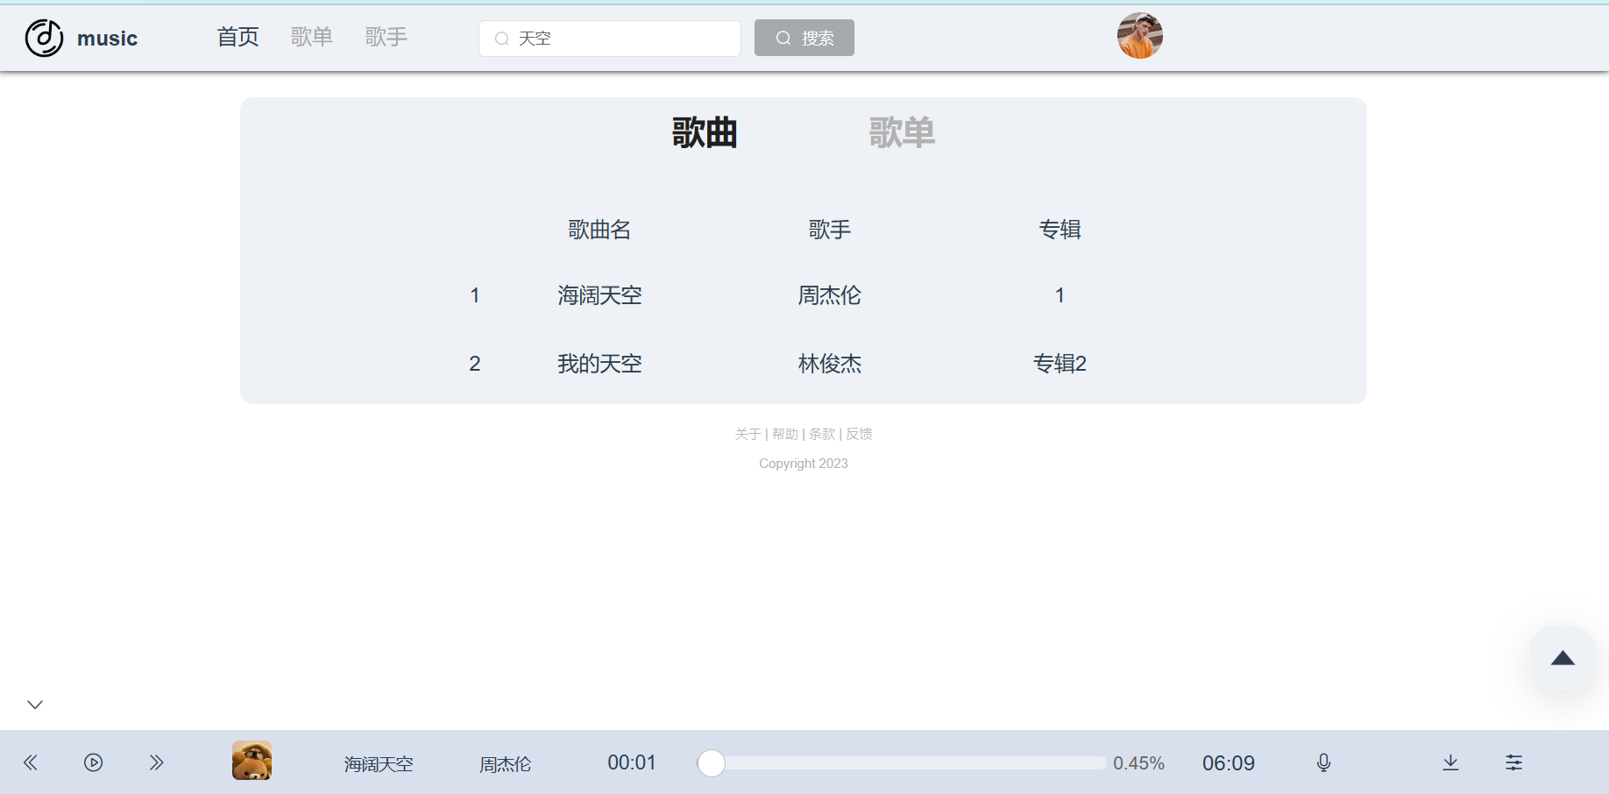

Song search page shows the songs that contain the keywords entered in the search box, click it to jump to the corresponding song details page.

song list search page:

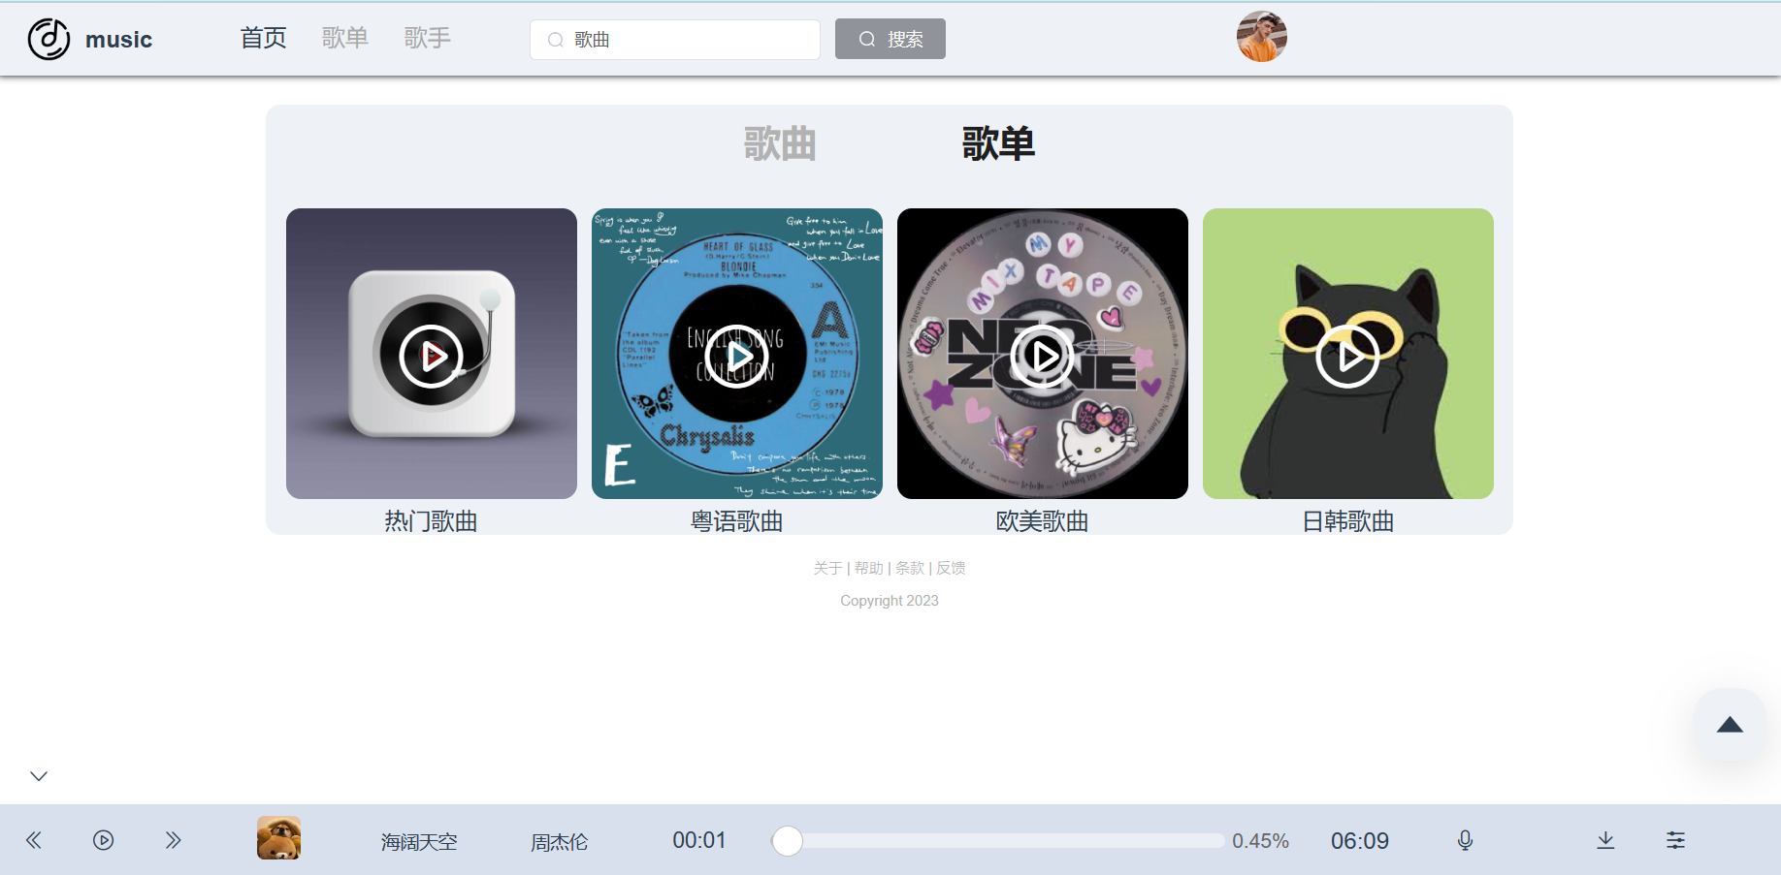

Song list search page displays song lists that contain the keywords entered in the search box, and clicking on them takes you to the corresponding song list details page.

song detail page:

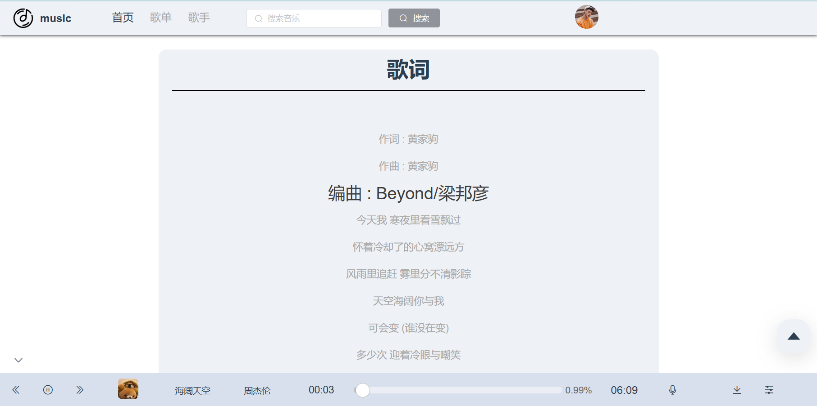

Song details page shows the current lyrics according to the playing progress.

modify avatar page:

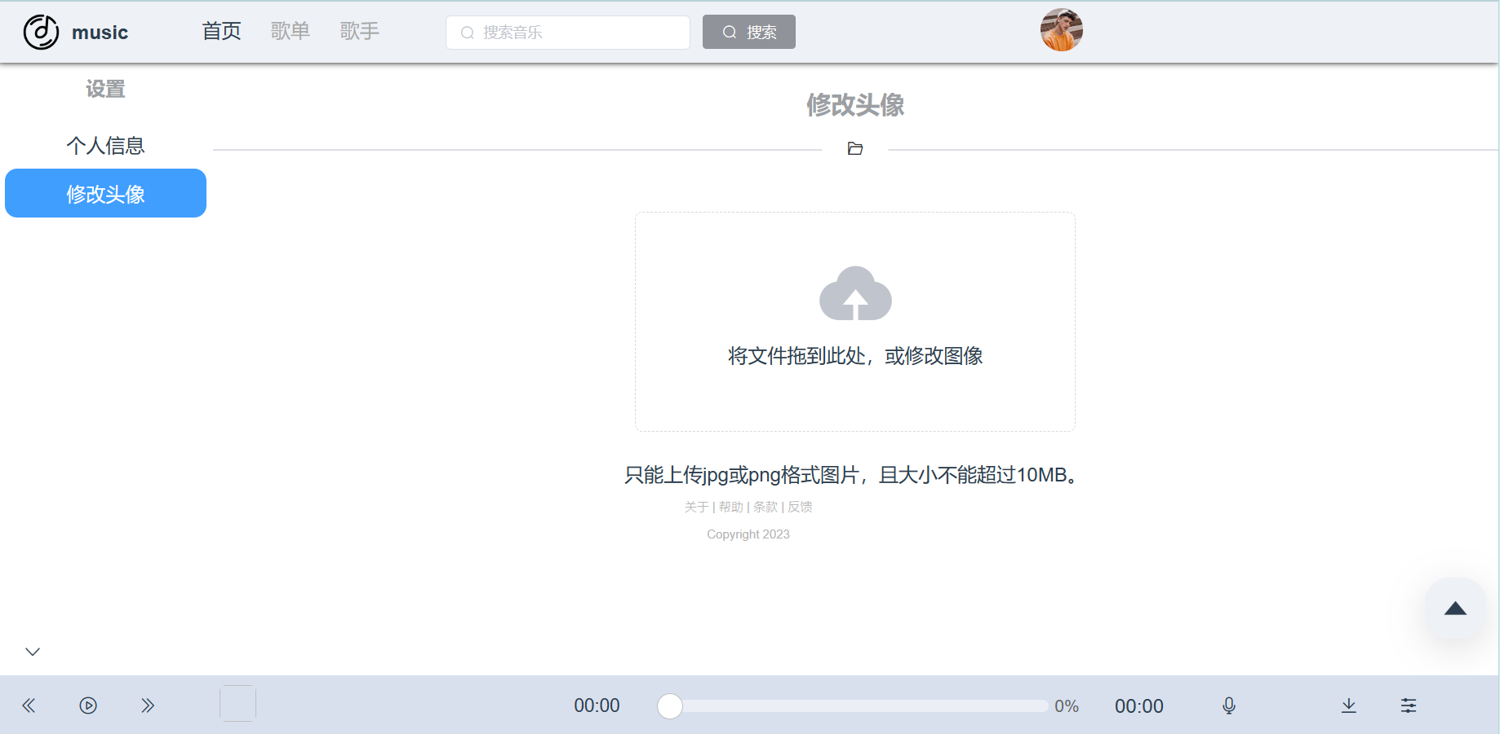

You can upload a user avatar. You can click and drag to upload a picture.

modify information page:

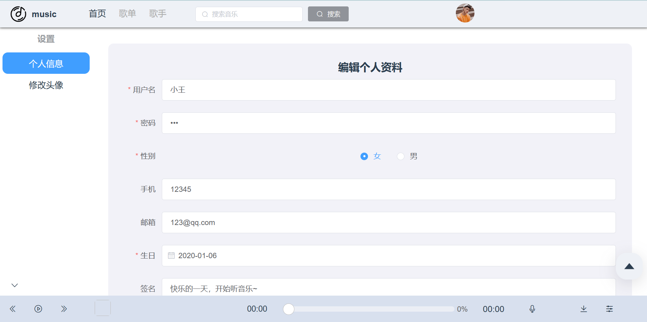

You can edit personal information and submit it.

**Component Design**

header navigation bar:

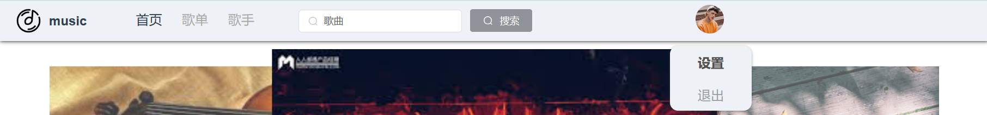

The top navigation bar can be clicked to jump to different pages, display user avatar, click avatar to enter the settings page and exit login. Search box can search songs and song list.

bottom navigation bar:



Bottom navigation bar shows the current song, you can play the previous and next song, click the picture to enter the song details page, you can drag the progress bar to adjust the progress of the song. You can adjust the music volume and download the song. You can display the playlist.

back to top button:



Back to top button, click it to return to the top of the page.

Playlist:

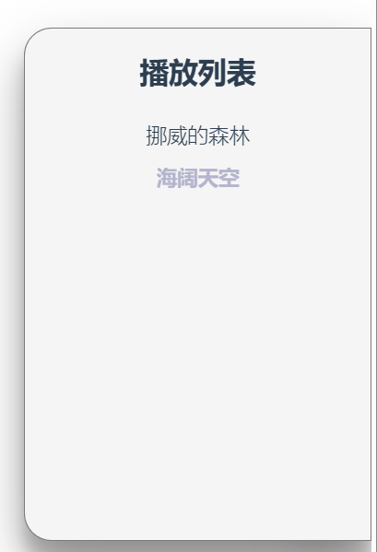

Playlist, show the list of playing songs, click to switch songs.

**back end:**

**Pages Design**

login page:

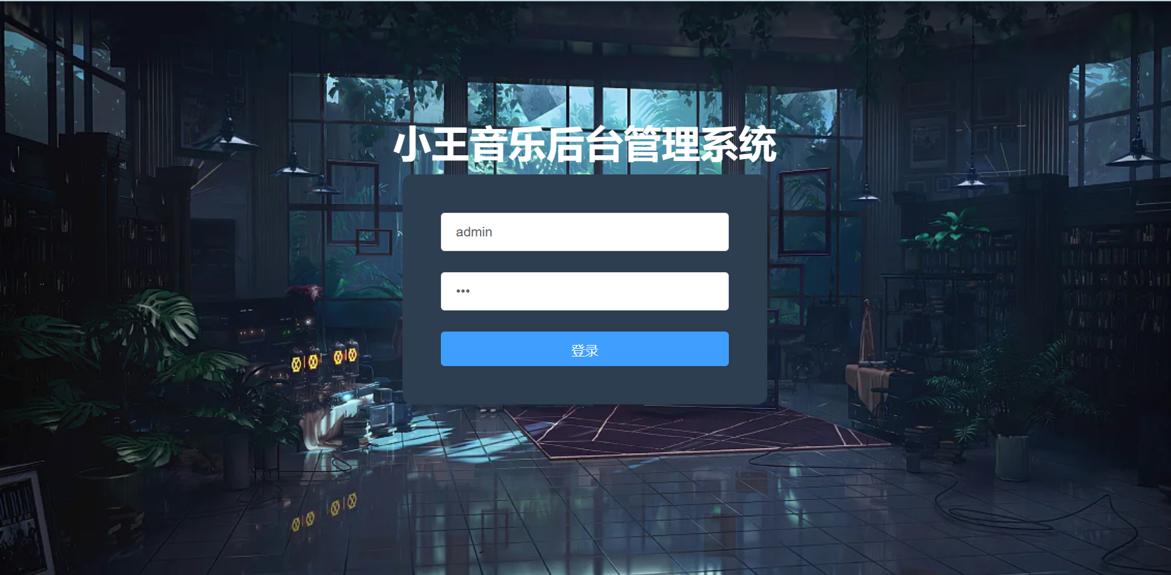

Administrator login screen, enter user name and password.

home page:

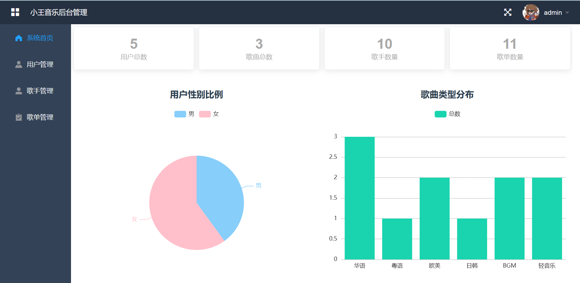

Home page of the system, which visually displays some information about the website including the total number of users, the gender ratio of users and the distribution of song types.

user management page:

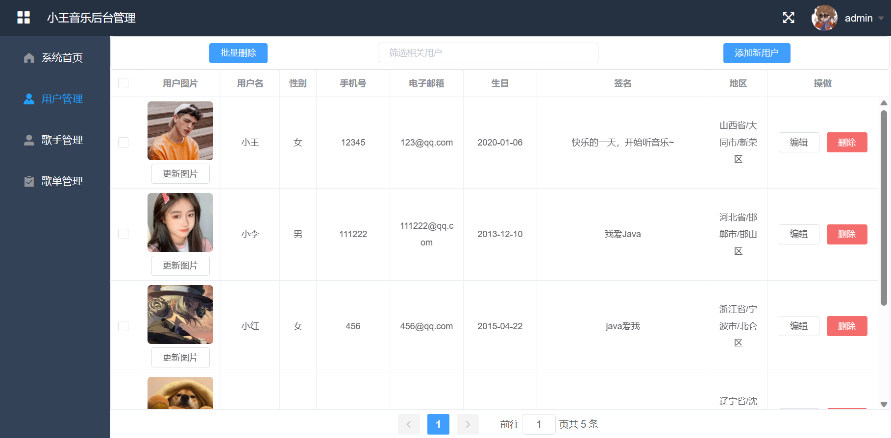

User management interface, administrator can modify user's avatar and information, add and delete users, search for users. You can also delete users in batch.

singer management page:

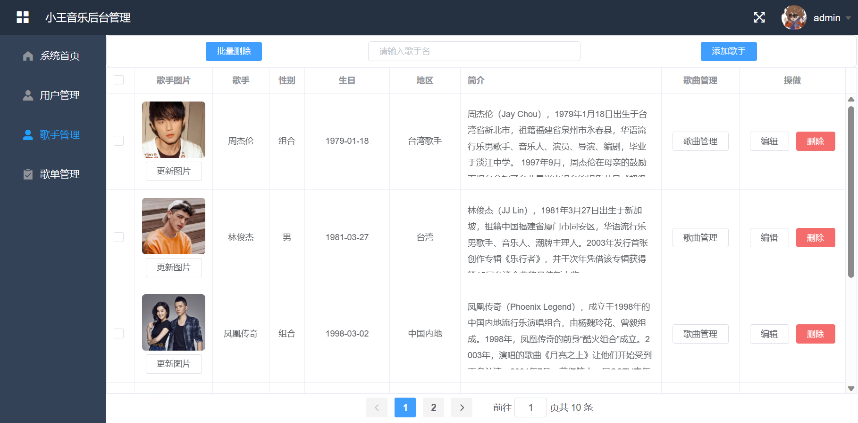

Singer management interface, the administrator can modify the singer's avatar, information, add and delete singers, search singers. You can also delete singers in batch. Click Song Management to enter the song management interface of the singer.

song list management page:

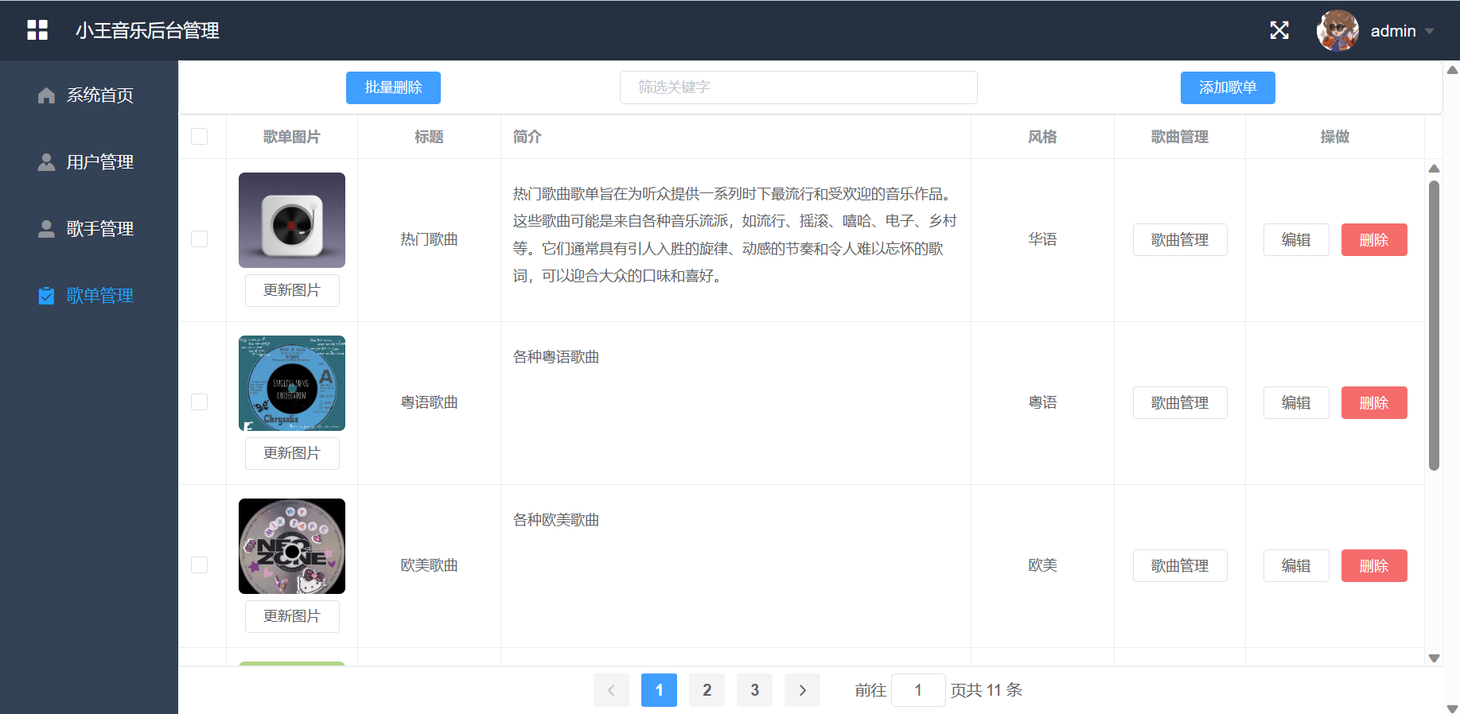

Song list management interface, administrator can change song list image and information, add delete song list, search song list. You can also delete songs in batch. Click Song Management to enter the song management interface of the song list.

singer song management page:

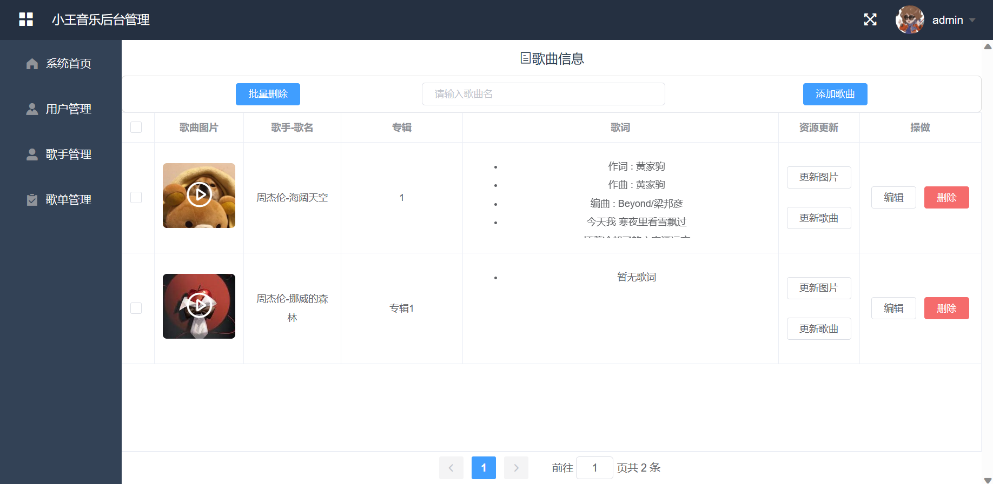

The singer's song management interface can play and pause the song, also can update the song and manage the song information. You can add, delete, and change songs.

song information page:

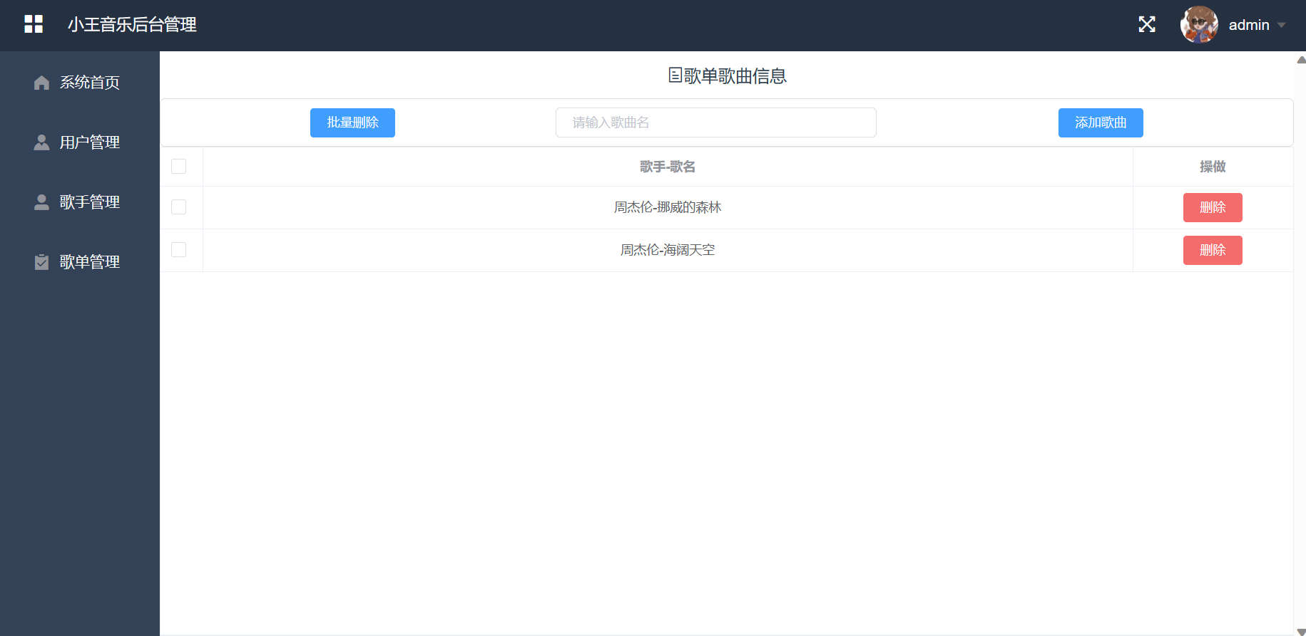

You can add, delete, and retrieve songs in the song list on the song management screen of the song list.

**2.3.2 Database design**

admin table:

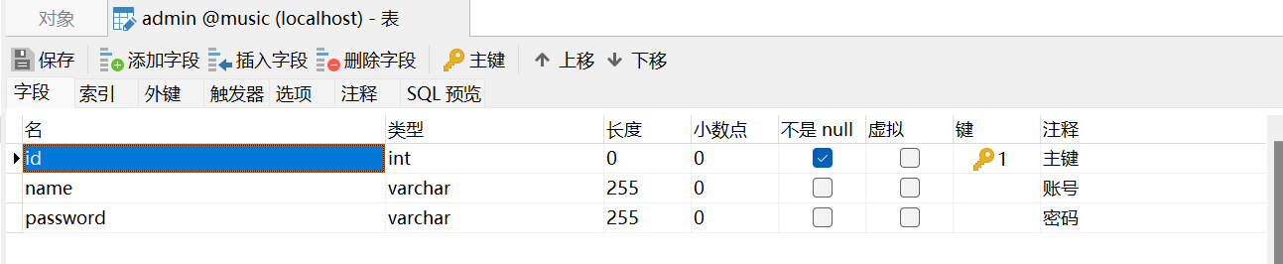

consumer table:

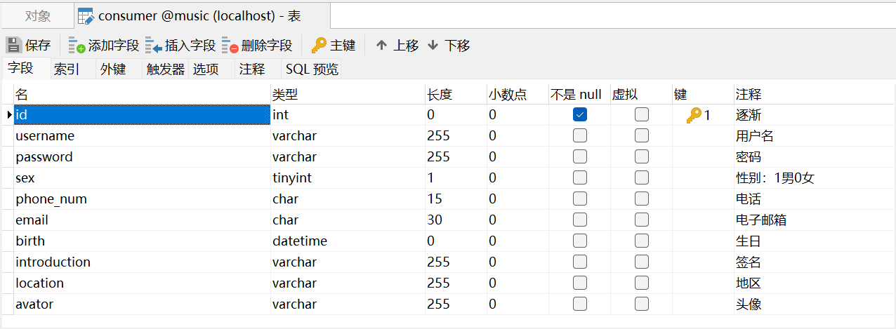

singer table:

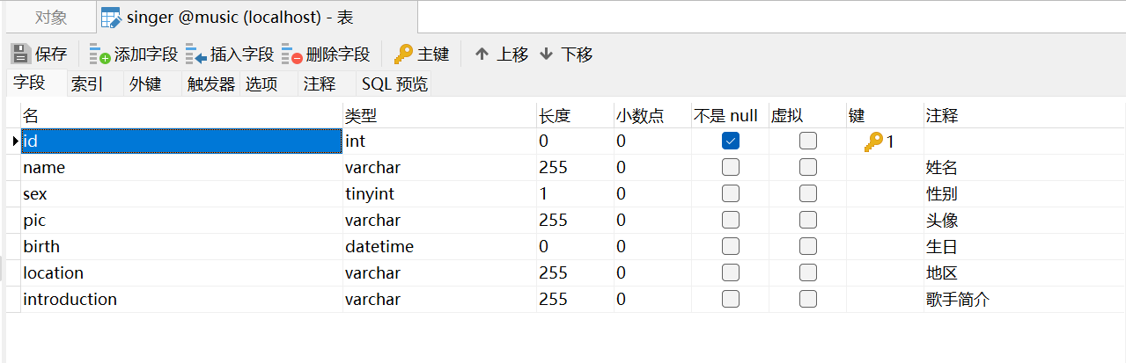

song table:

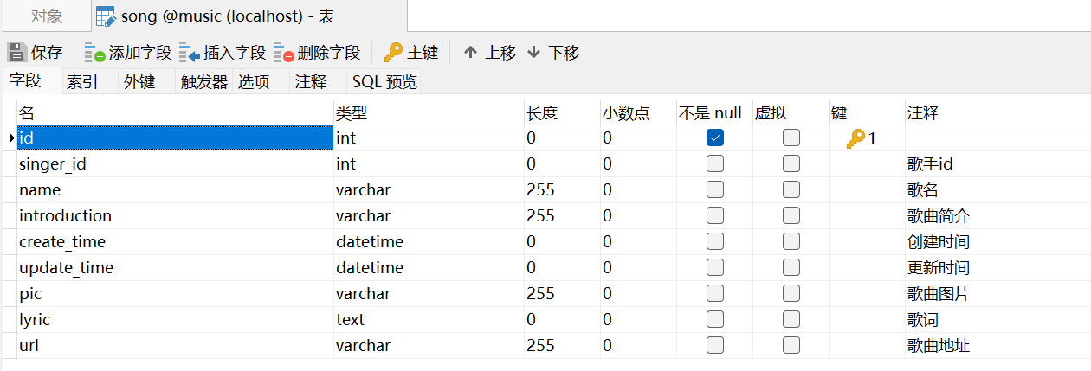

song list table:

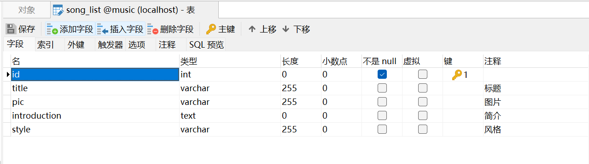

list song table:

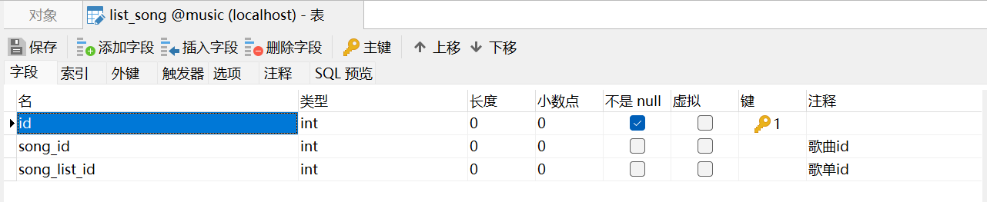

**2.4 Code implementation**

**2.4.1 login function implementation**

**Entity:**

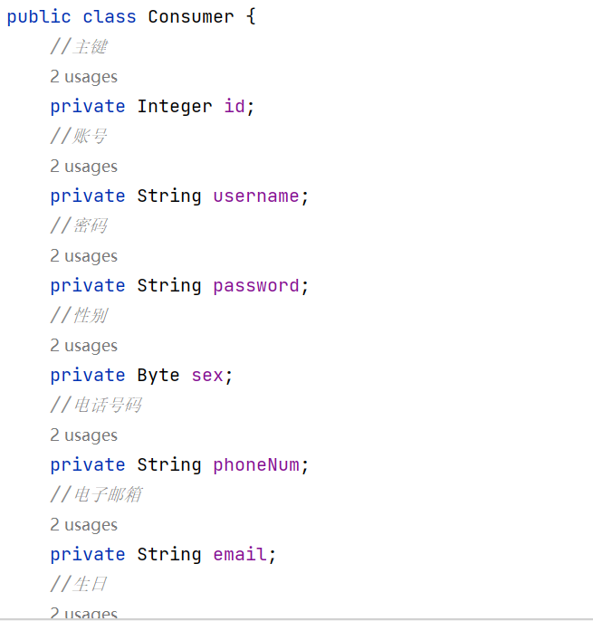

Entities contain properties and methods to describe and manipulate the characteristics and behaviour of that object.

**Mapper:**

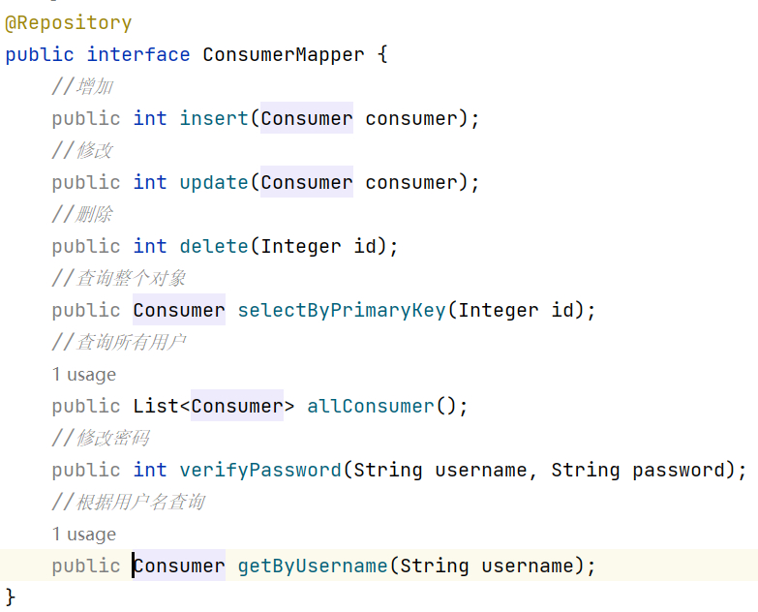

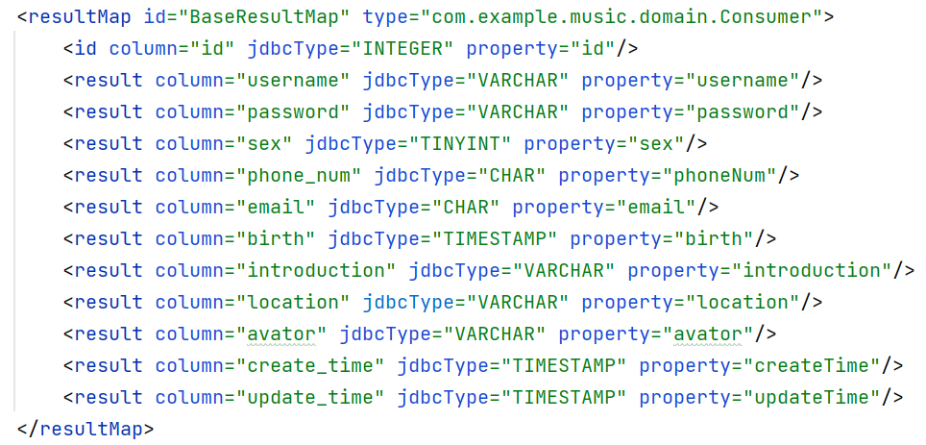

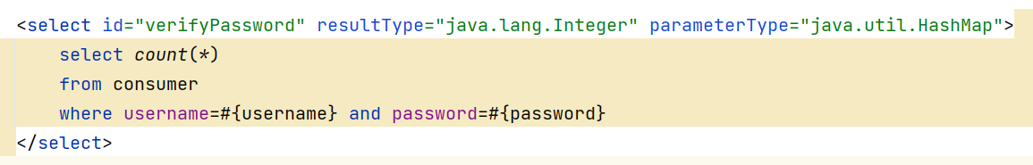

A mapper is used to handle the mapping relationship between an entity object and a data store, such as a database. It is responsible for converting data retrieved from a data store into entity objects and saving the entity objects back to the data store. A mapper typically contains methods for reading and writing data for conversion and interaction between an entity object and a data store.

**Service:**

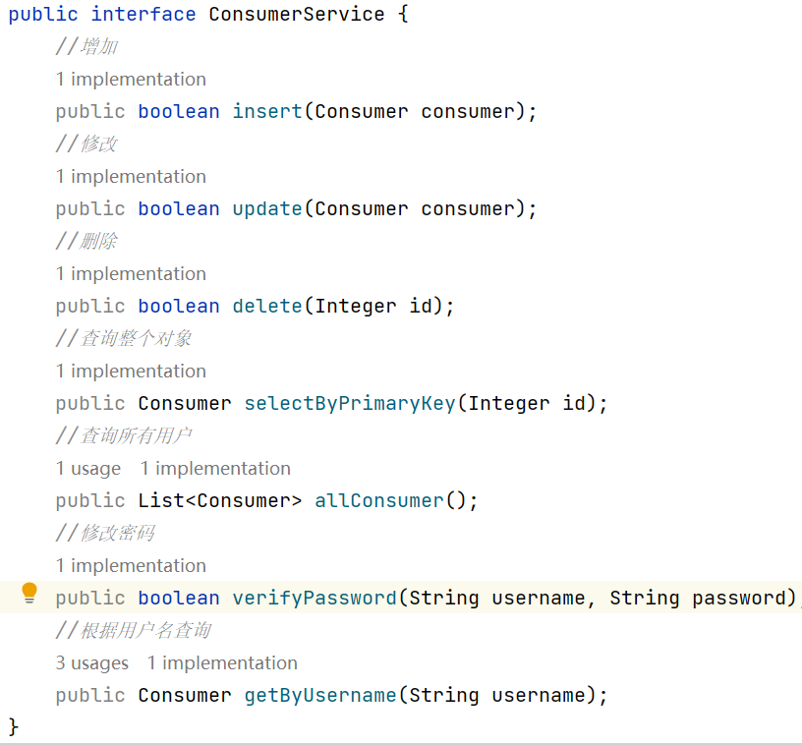

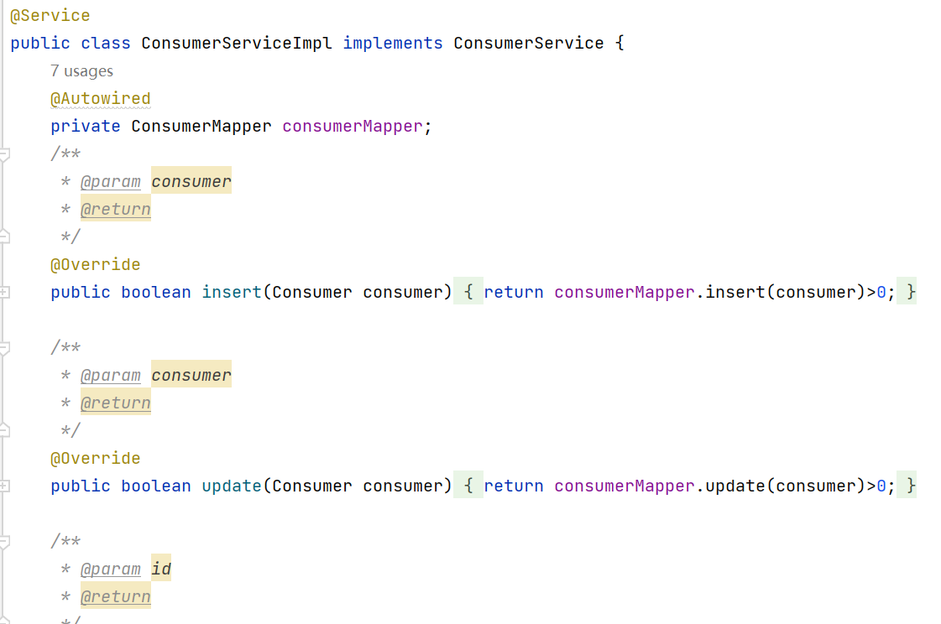

A service is a component used to execute specific business logic. It encapsulates the business logic, handles requests from the controller, and interacts with entities and data stores.

**Controller:**

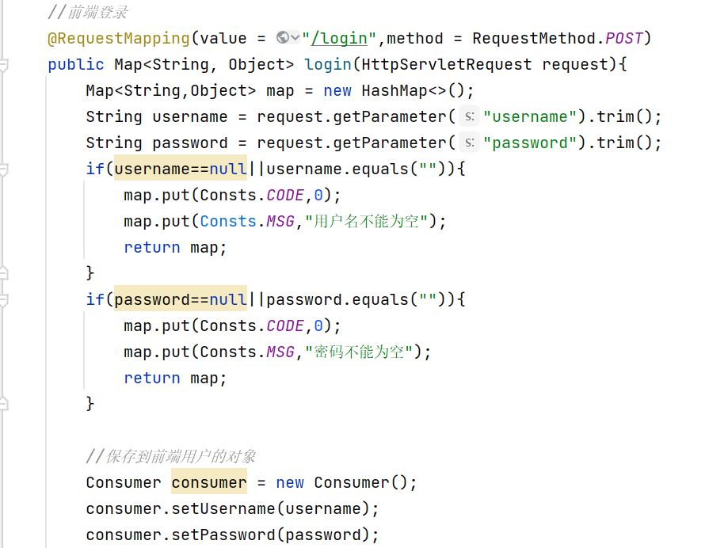

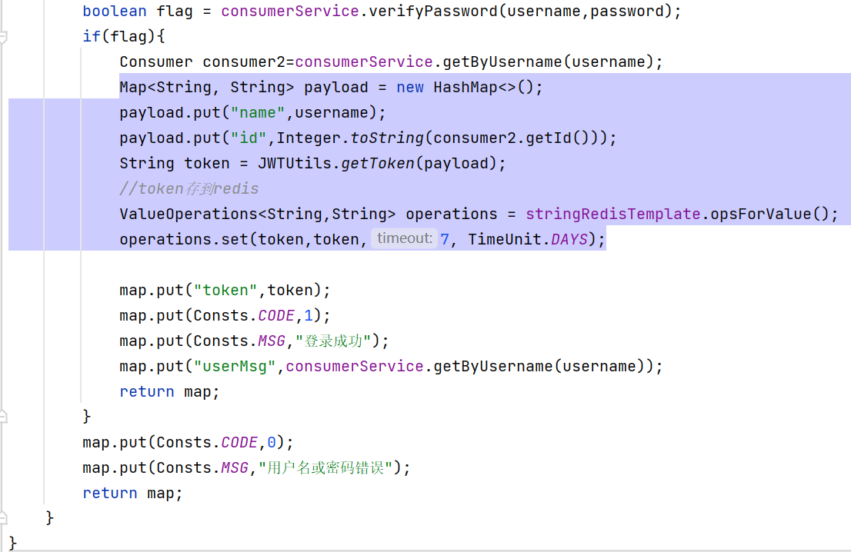

The controller receives input from the user interface and calls the appropriate service based on the input to execute the business logic. It is also responsible for passing model data to the view for display.

**JWT Usage:**

Why use JWT?

Cross-domain support: Since JWT is passed a token in the request header or URL parameter, it can be easily transferred across domains.

Security: JWT uses digital signatures or encryption to verify the authenticity and integrity of tokens, which can be used to enable servers to authenticate and authorize users by including relevant information about the user, such as a user ID or role.

JWTUtils:

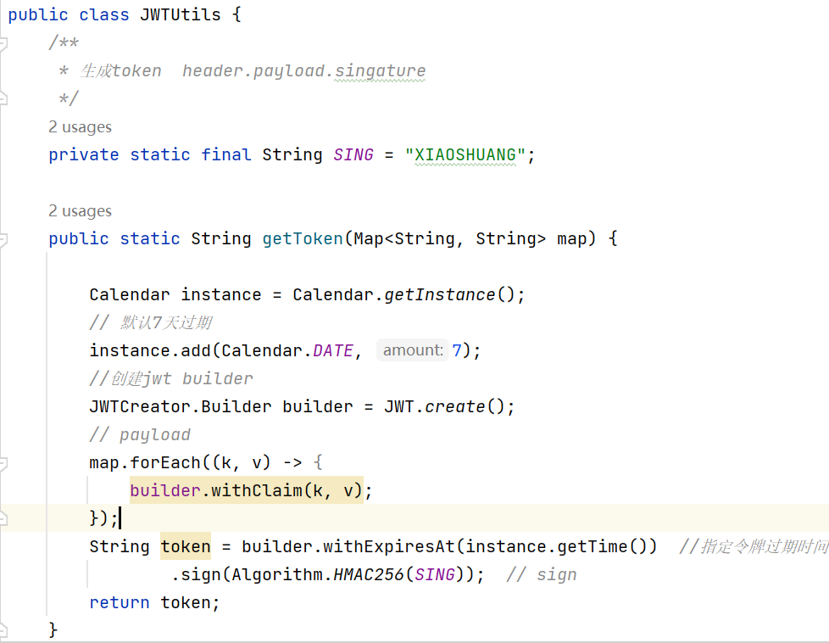

Generate token at login and pass it to the user:

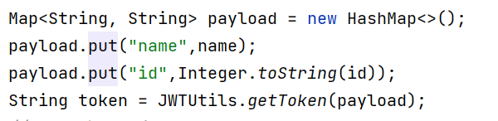

Creating a JWT Interceptor and using it:

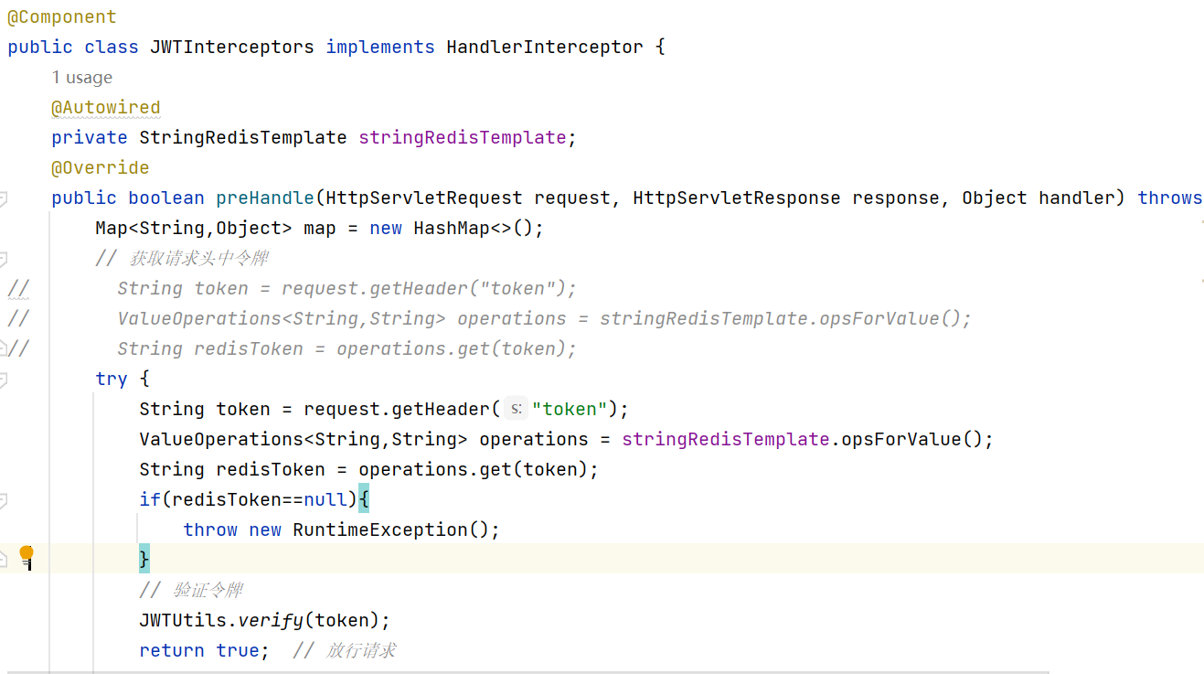

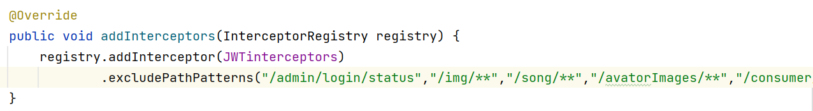

**Redis Usage:**

Why use Redis?

Redis is an open source in-memory data storage system that provides key-value pairs data structure. Redis supports persistence, which allows you to store data on your hard drive, and is highly scalable and high performance.

When the user changes the password, it should invalidate the user's previous token, which can be stored in Redis.

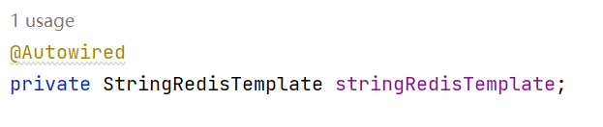

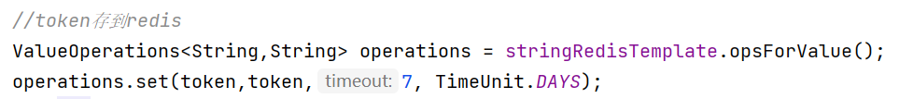

Delete token in Redis when changing passwords:

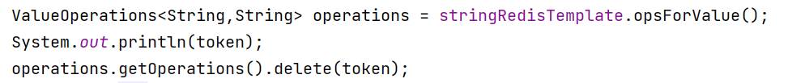

**Test:**

The administrator logs in and the backend transmits the value of the token to the frontend.

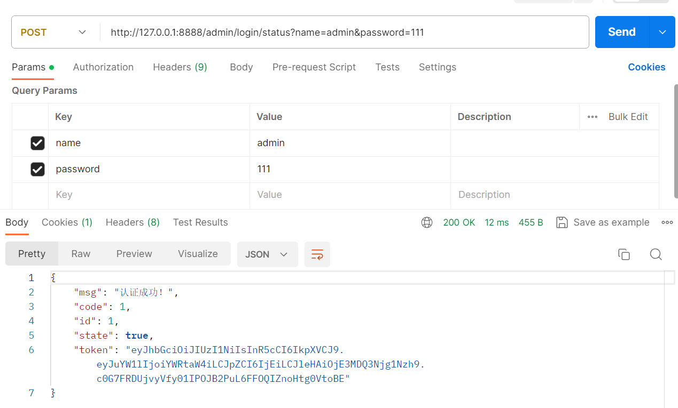

The value can be seen stored in Redis.

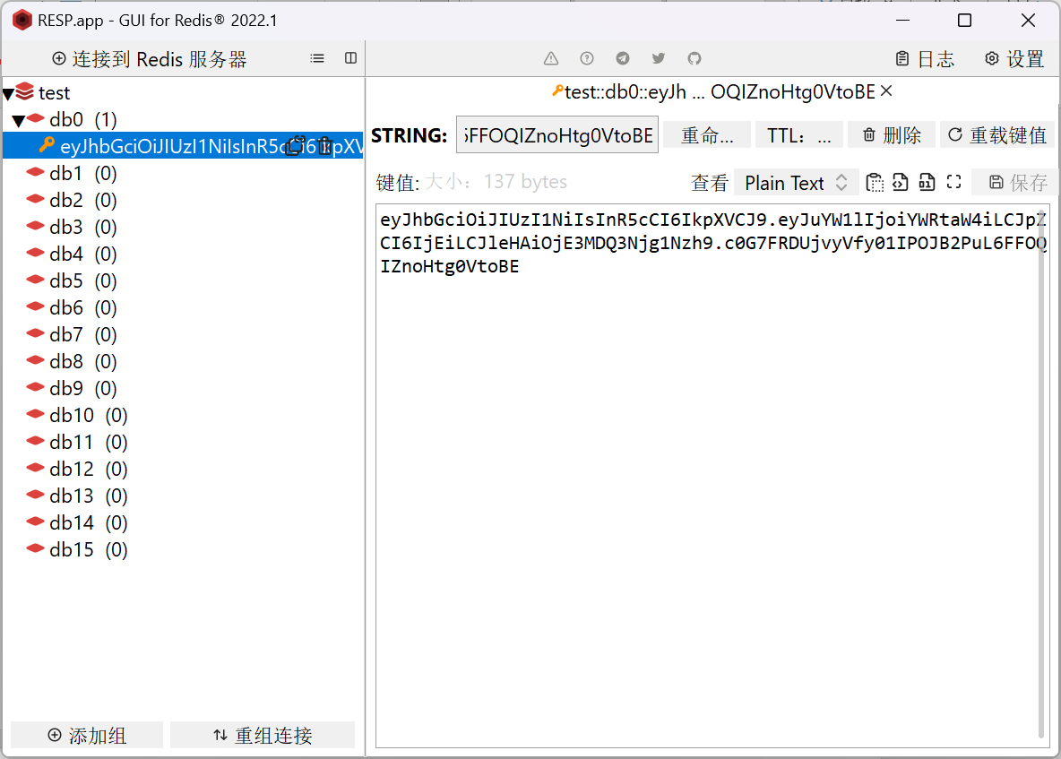

If you don't add token in headers, see the backend return token invalid message.

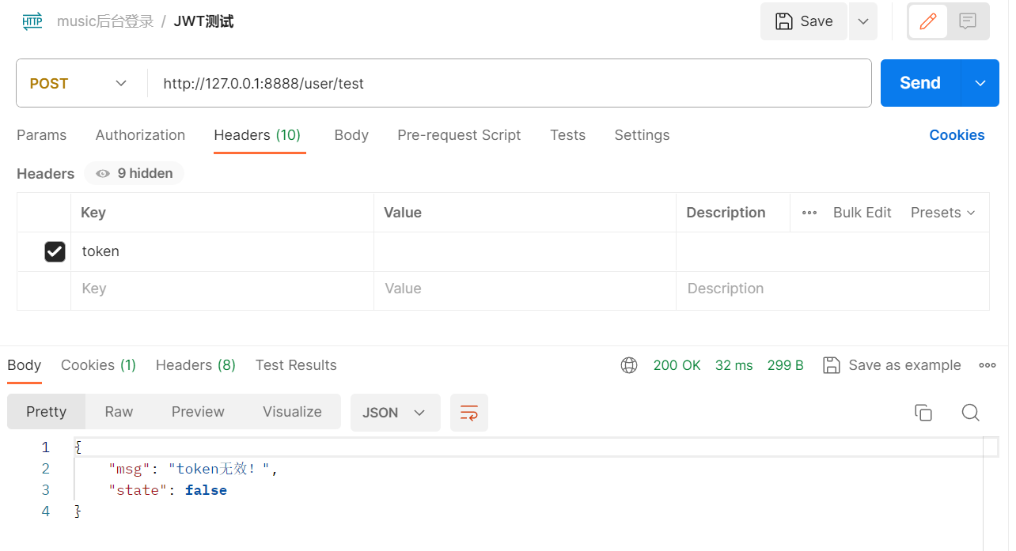

Copy the token you just made into headers to see the message that the request was successful.

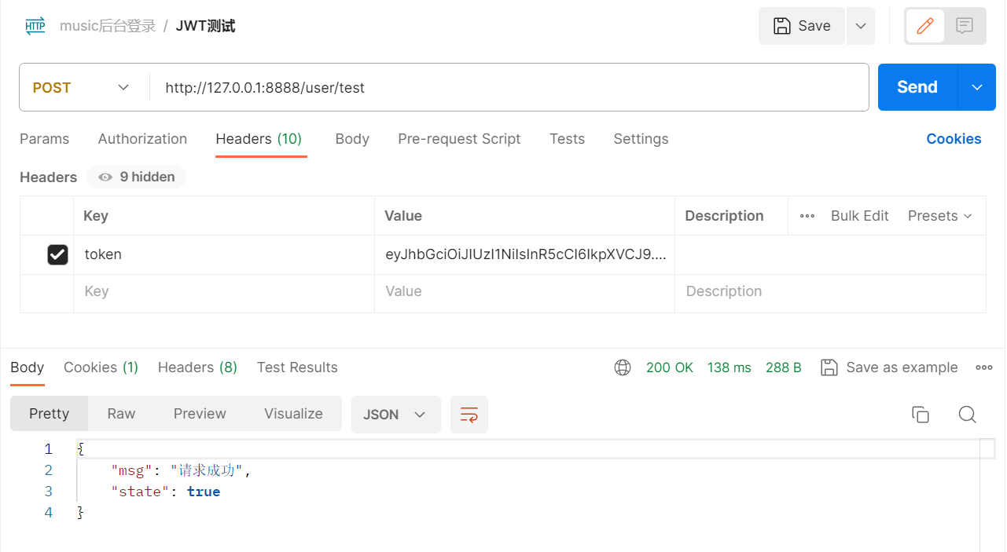

Change the administrator password.

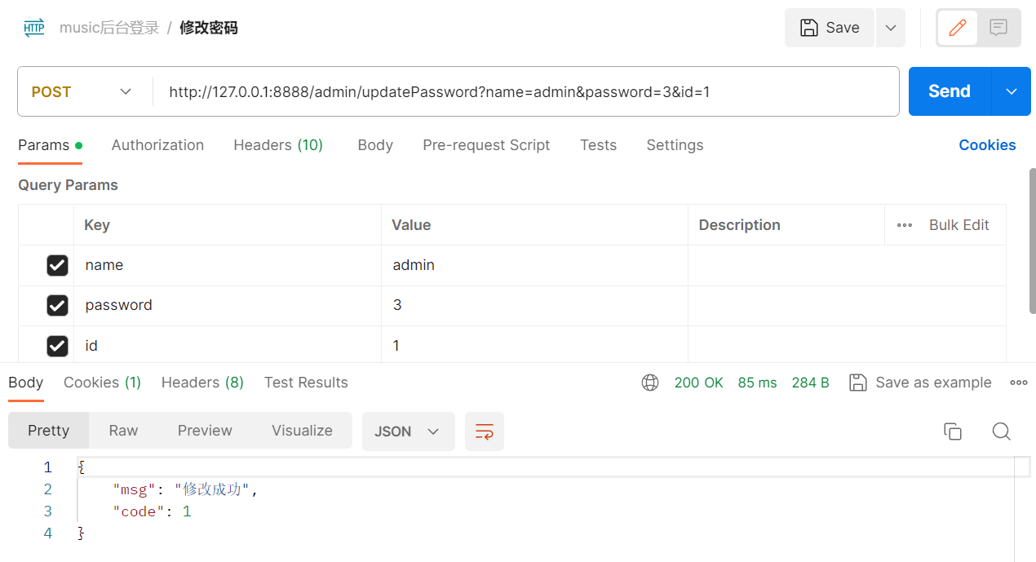

You can see that the token has been removed.

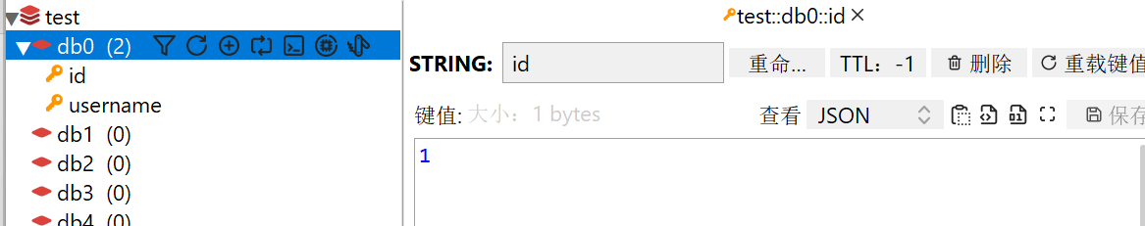

Using the original token reveals that the token is invalid.

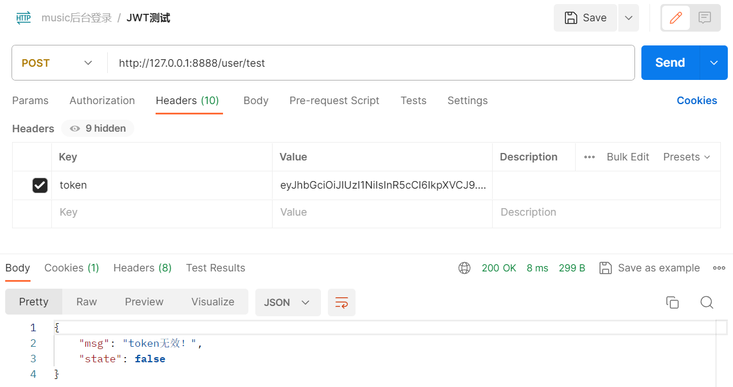

**The front end receives the token and uses it:**

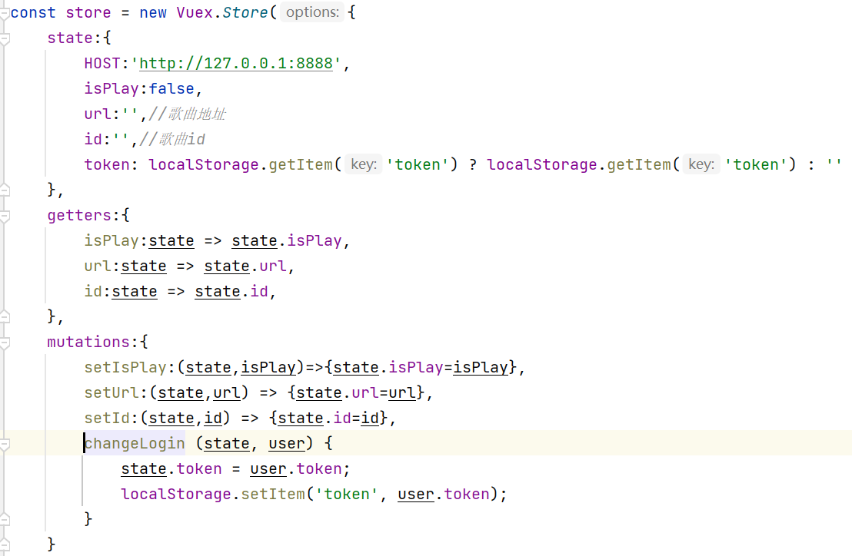

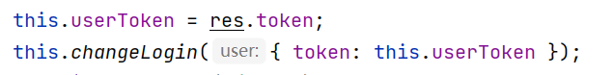

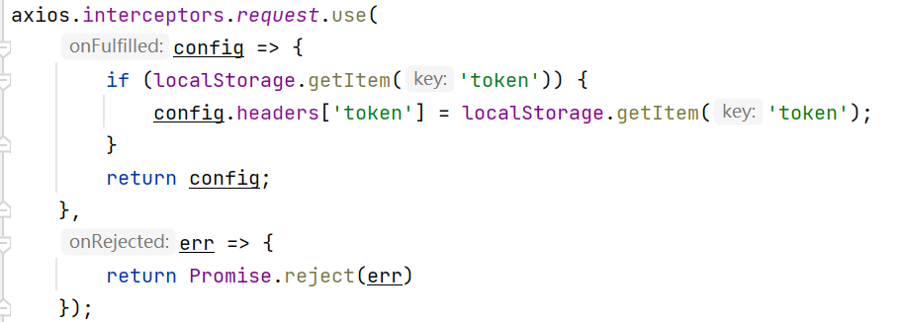

**2.4.2 song upload function implementation**

**Entity:**

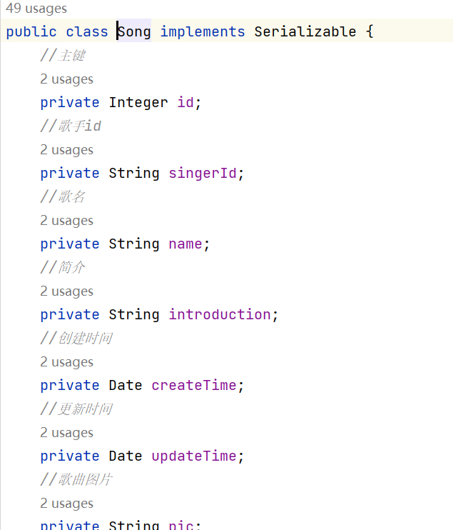

The song entity class contains the various properties of the song and the corresponding get and set methods.

**Mapper:**

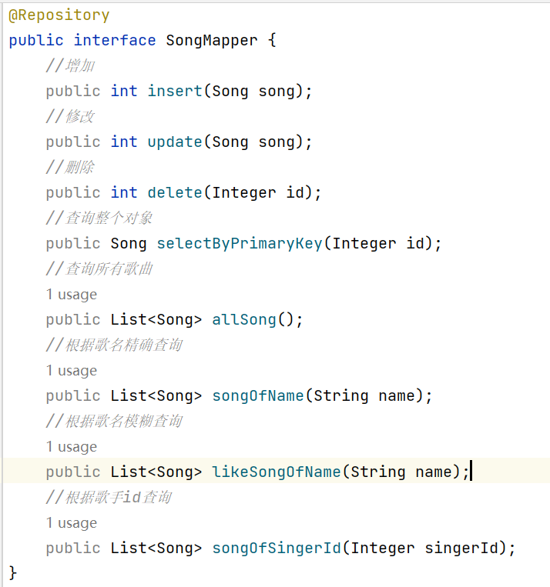

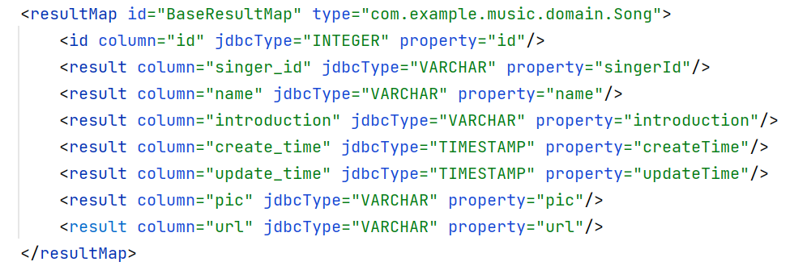



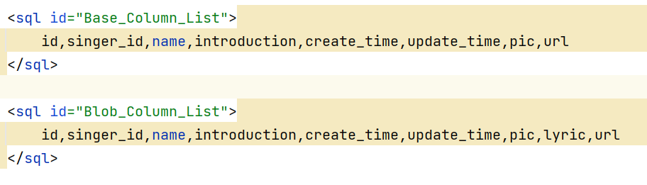

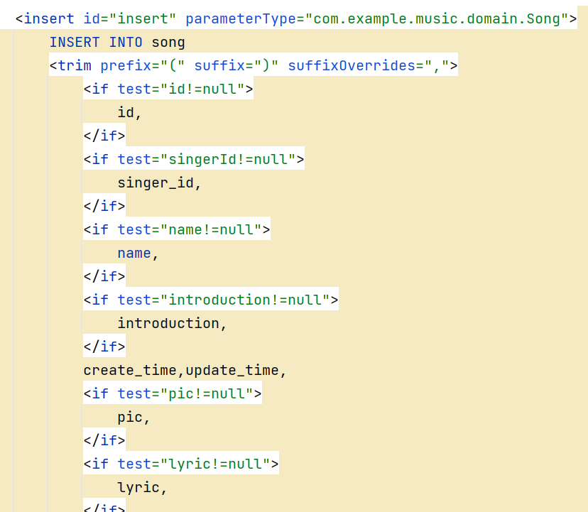

Database manipulation of song using Mybatis.

**Service:**

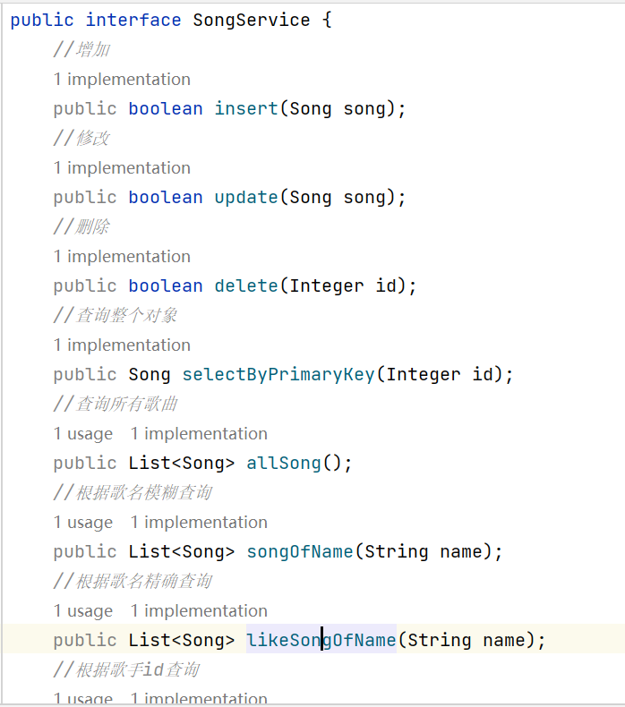

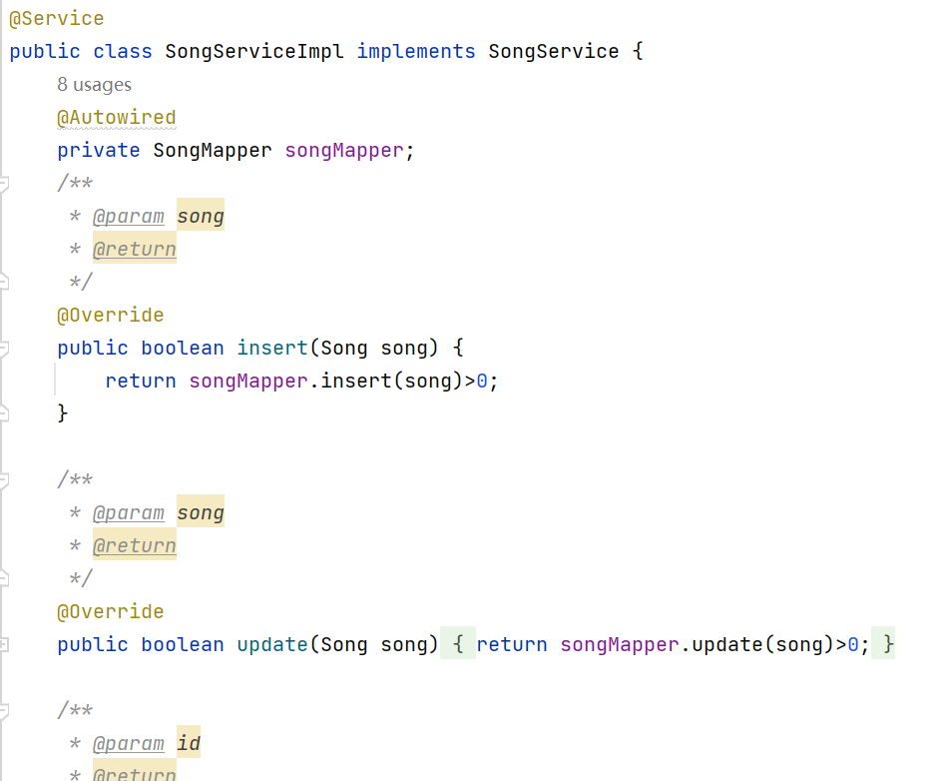

Song service class implements the business logic for song manipulation.

**Controller:**

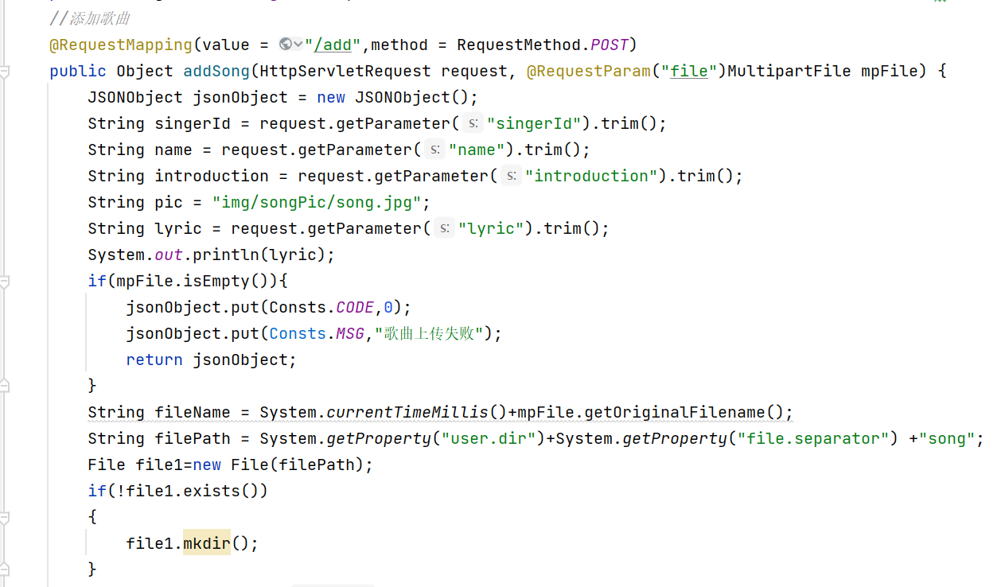

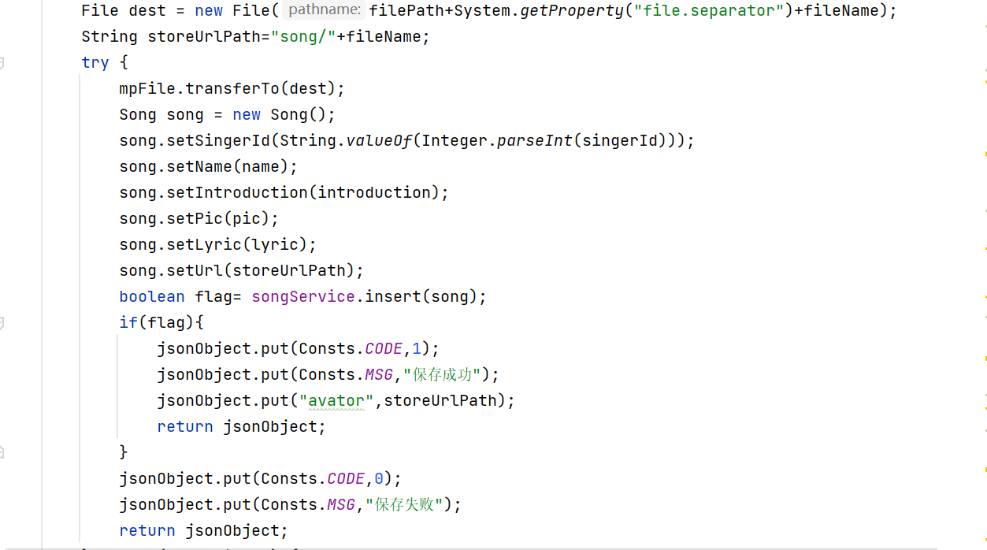

The Controller receives the file from the front end and saves it to the specified path and stores the song information to the database.

**Configuration:**

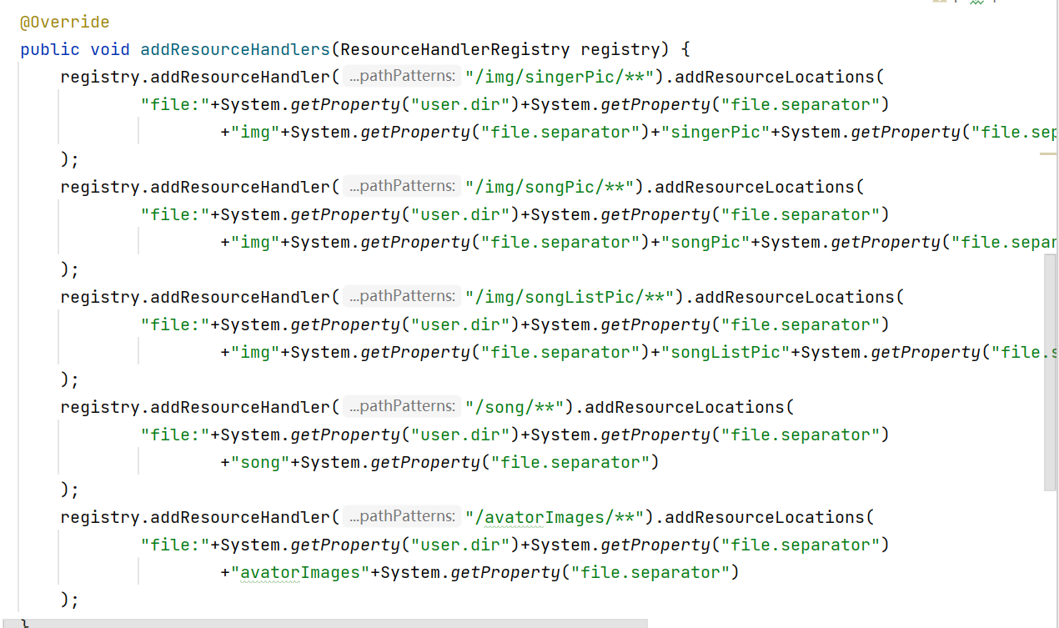

Spring MVC's configuration method for configuring processors for static resources. It registers multiple resource handlers through the addResourceHandlers method for mapping different resource paths to actual file system paths to be able to access and display these static resources in the web application.

**The front end:**

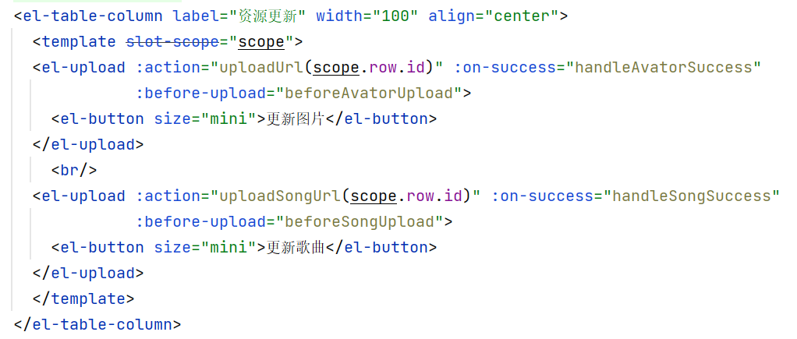

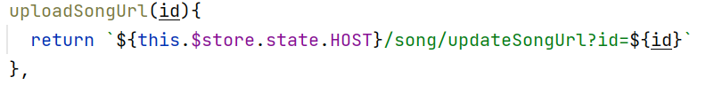

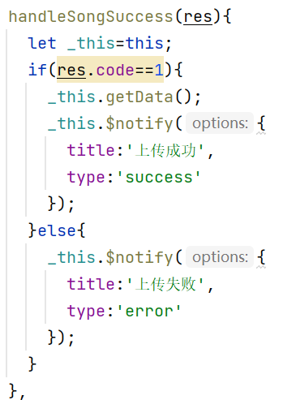

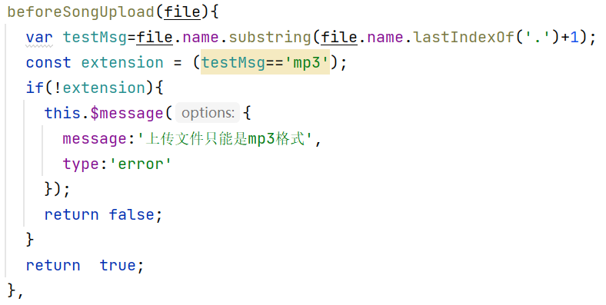

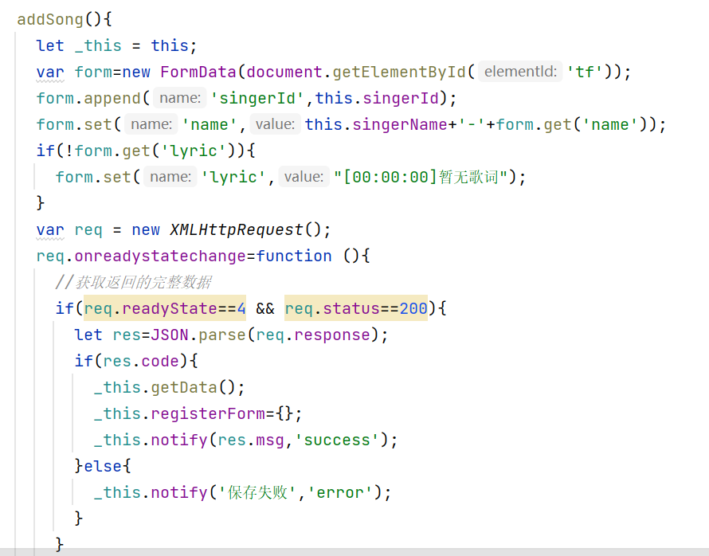

**2.4.3 search song function implementation**

Controller:

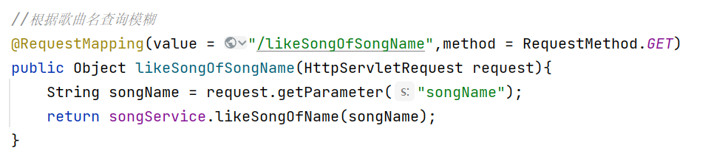

Service:



The % is a wildcard character that indicates a placeholder that can match any character. In LIKE fuzzy searches, % can be placed before, after, or both of the keywords to achieve different matching patterns.

Mapper:

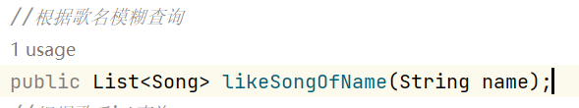

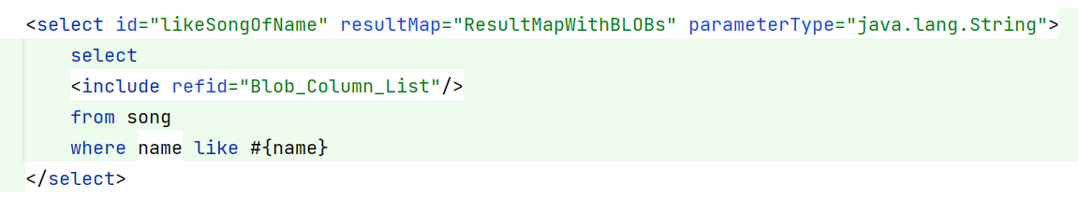

**The front end:**

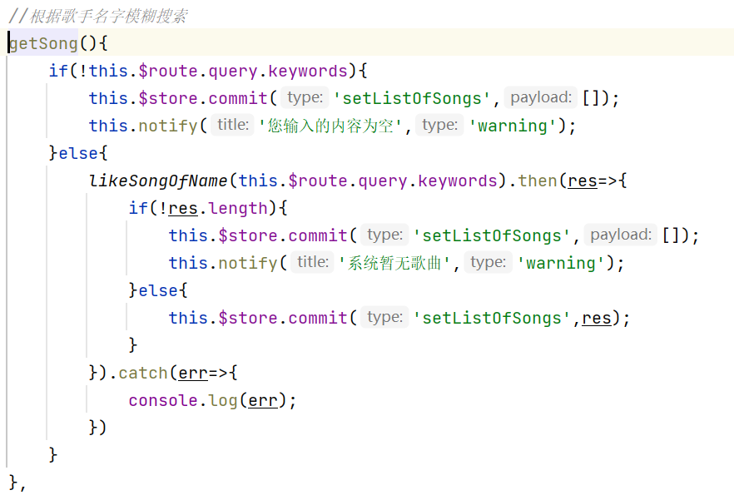

**3 Testing and Evaluation**

**3.1 Functional test evaluation**

Backend login page test:

Successful login test:

Steps:

Open the login page.

Enter a valid username and password.

Click the Login button.

Expected Result:

Login is successful and the user should be redirected to the home page or another page after login.

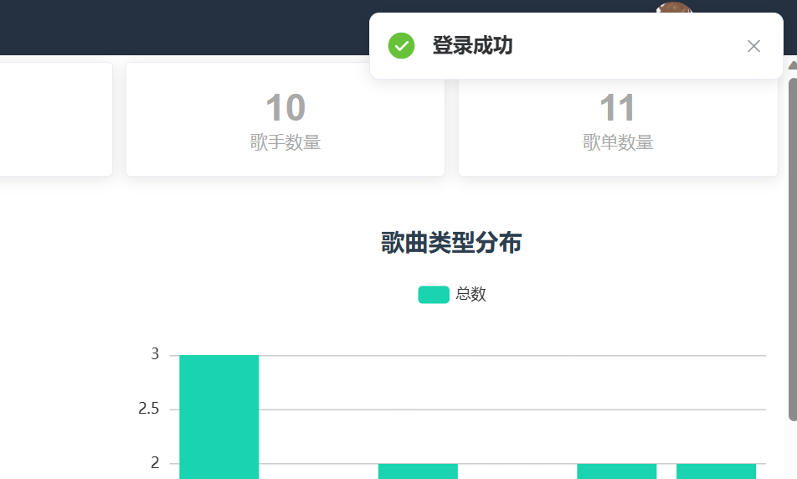

Login failure test:

Steps:

Open the login page.

Enter an invalid username and a valid password.

Click the Login button.

Expected Result:

Login fails and the system should display an error message.

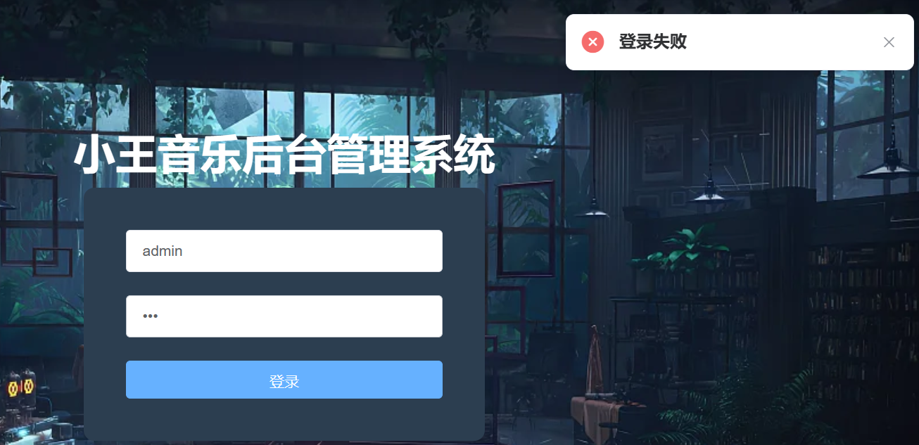

Song list management page test:

Steps:

Open the Song List Management page.

Verify that the song list details are displayed correctly.

Click Song Management to enter the song management page.

Verify that you can add, delete, change, and retrieve songs.

Verify that the song list cover can be changed.

Expected Result:

Song list details are displayed correctly.

Click Song Management to access the song management page.

Songs can be added, deleted, and retrieved.

Song list covers can be changed.

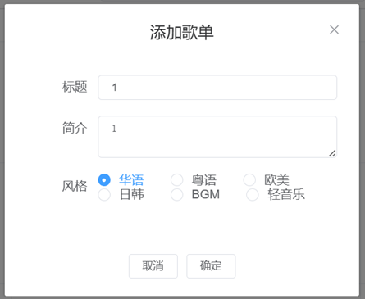

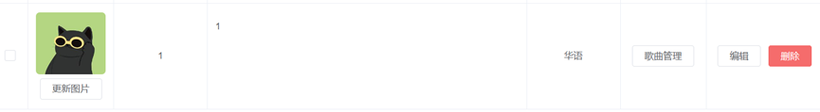

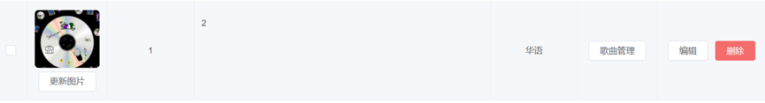

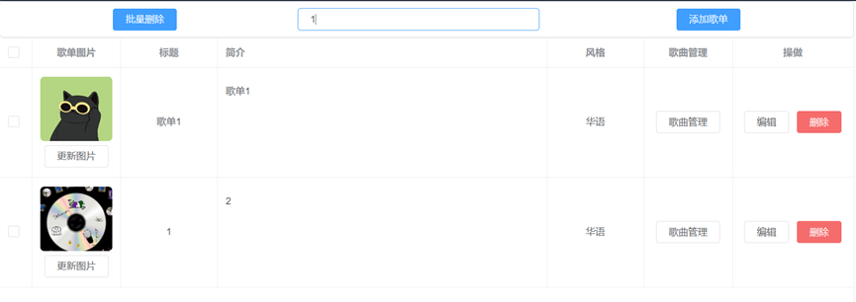

Singer admin page test:

Steps:

Open the Singer Admin page.

Verify that the singer's details are displayed correctly.

Click on Song Management to access the Song Management page.

Verify that you can add, delete, and check singers.

Verify that the singer avatar can be changed.

Expected Result:

Singer details are displayed correctly.

Click Song Management to access the song management page.

You can add, delete, and change singers.

Singer avatar can be changed.

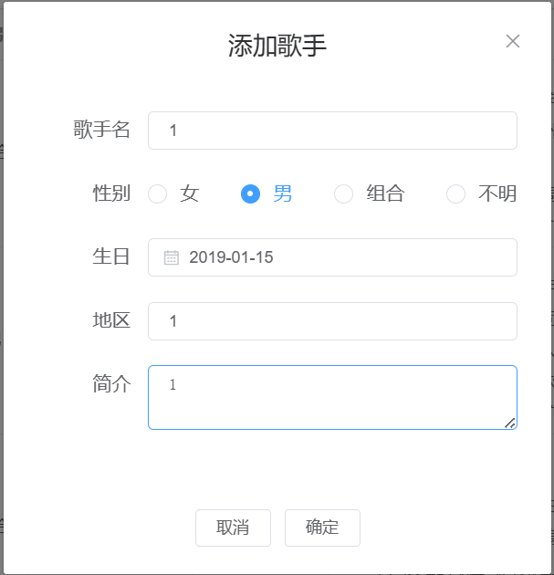

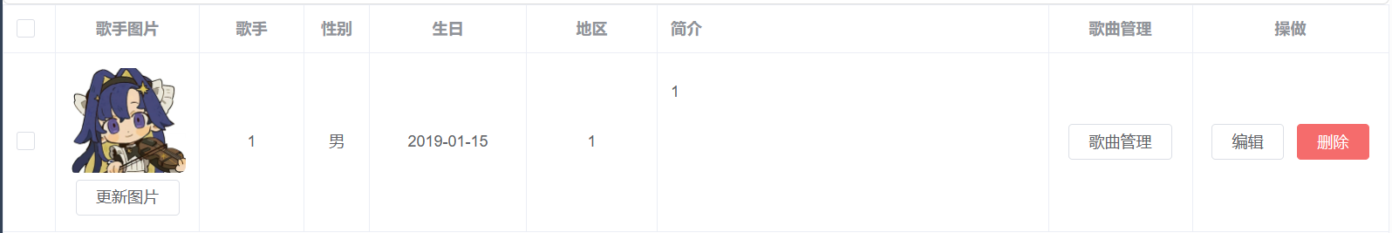

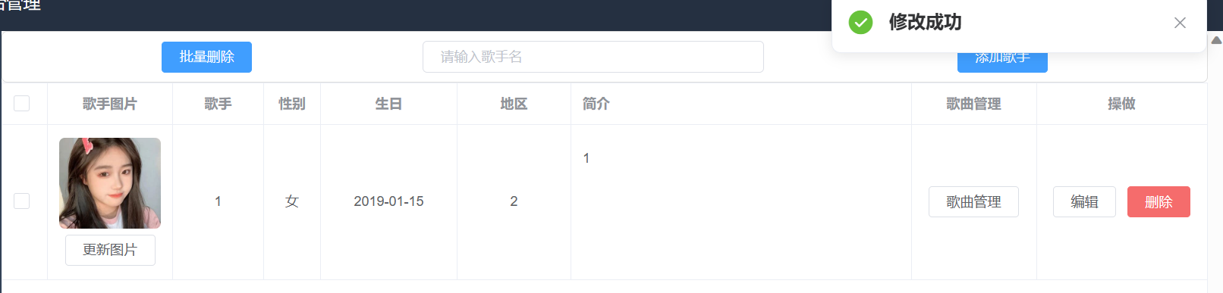

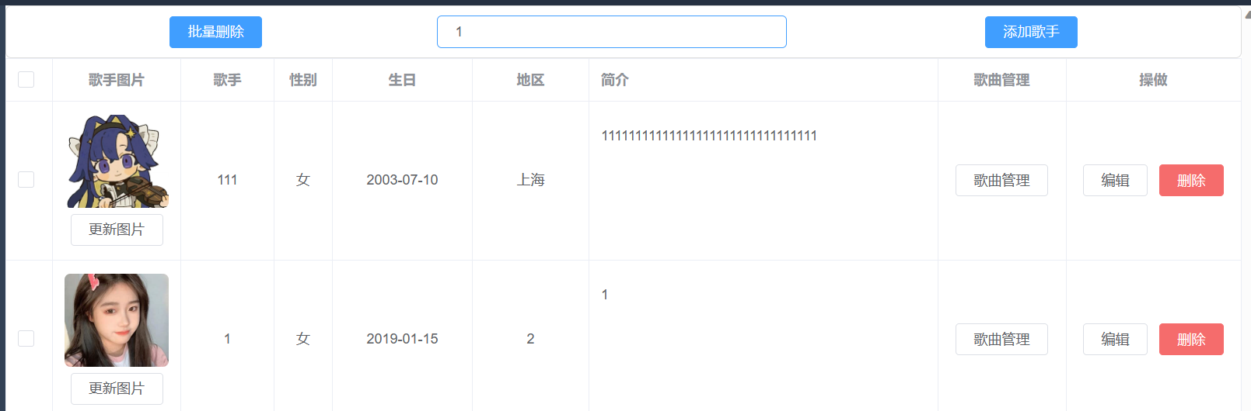

User management page test:

Steps:

Open the User Management page.

Verify that the user details are displayed correctly.

Verify that the user can be added, deleted, and modified.

Verify that the user avatar can be changed.

Expected Result:

User details are displayed correctly.

Users can be added, deleted, and retrieved.

User avatars can be changed.

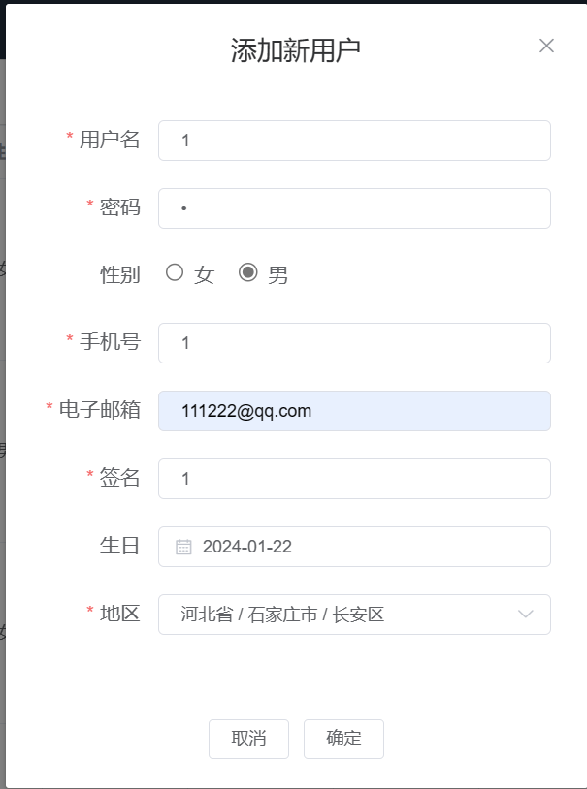

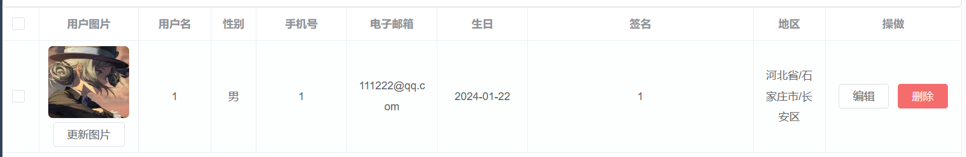

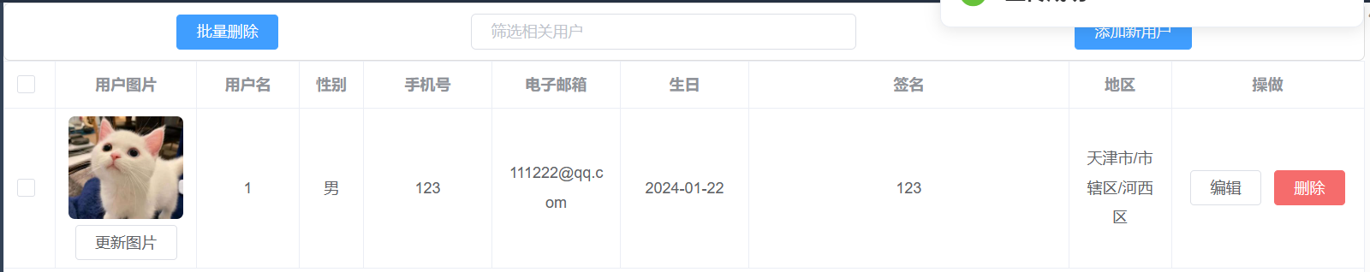

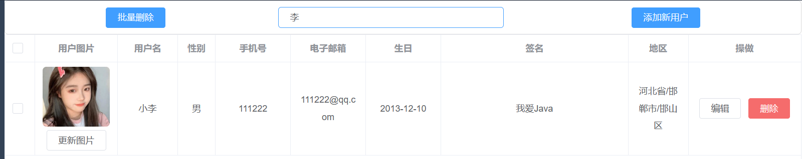

Singer songs page test:

Steps:

Select an artist and click on Song Management to go to the artist's song page.

Verify that the information about the song is displayed correctly.

Verify that the song can be played and paused by clicking on it.

Verify that you can add, delete, and change songs.

Verify that songs and song images can be updated.

Expected Result:

Information about the song is displayed correctly.

Songs can be played and paused by clicking on them.

Songs can be added, deleted, or modified.

Songs and song images can be updated.

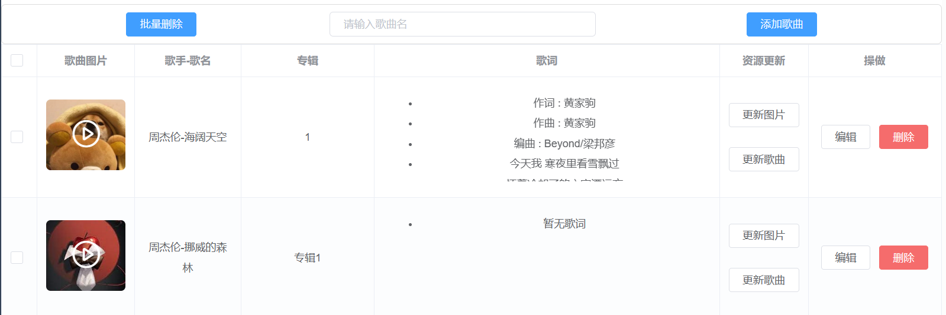

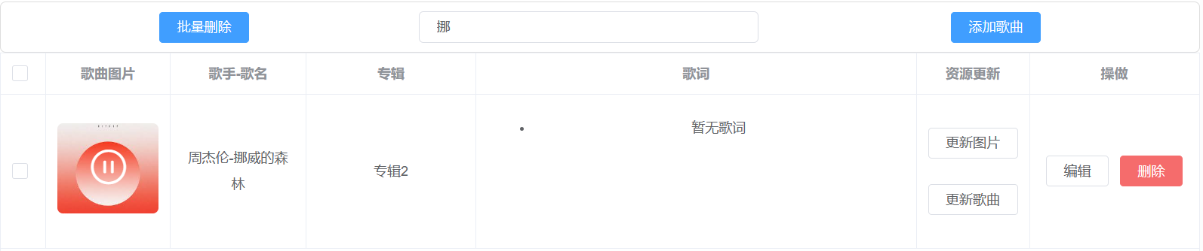



Go into full screen mode to test:

Steps:

Open the application or web page.

Find the Full Screen Mode button.

Click on the full screen button.

Expected Result:

The web page should be displayed in full screen mode, filling the entire screen.

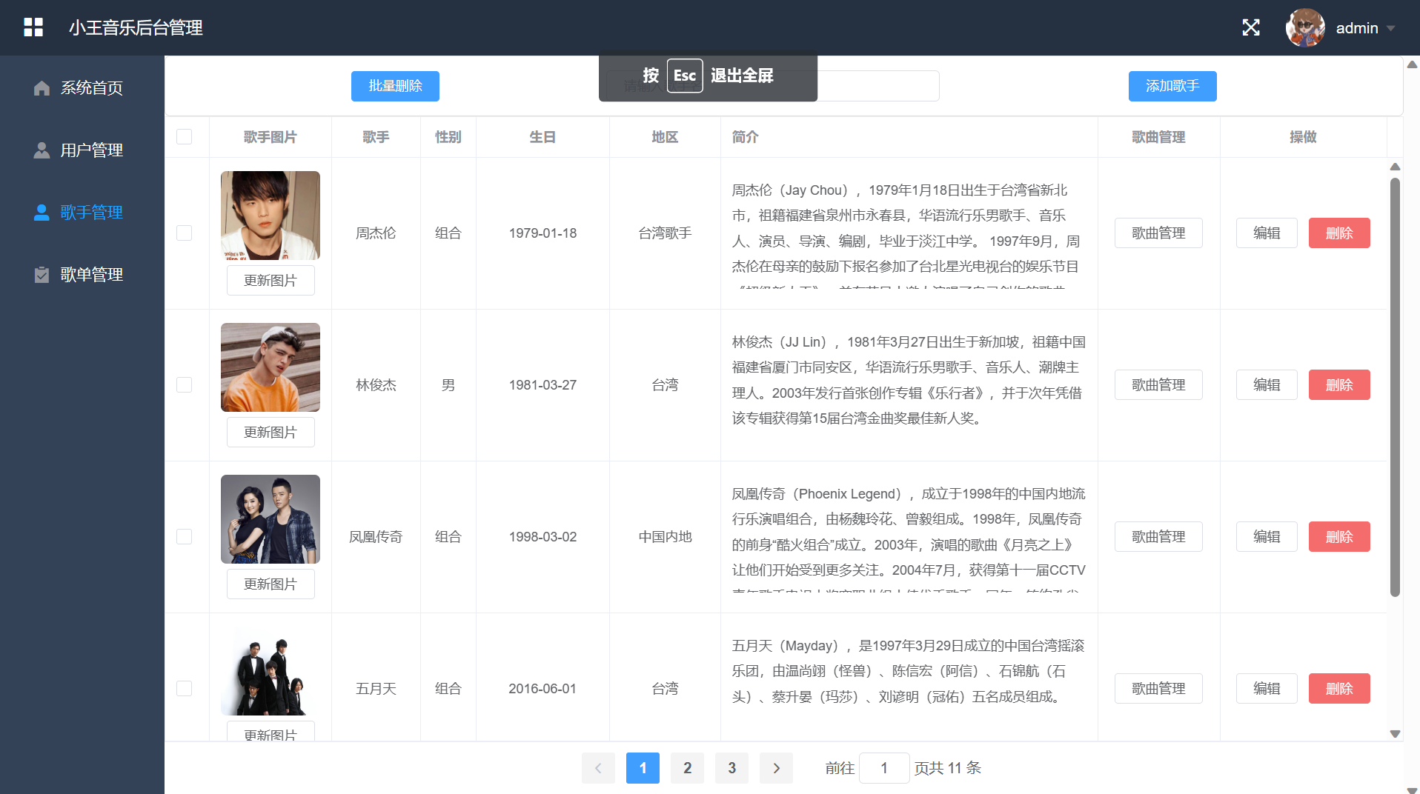

Change the password test:

Steps:

Click on the user name and click on Change Password.

Enter the new password.

Expected Result:

Log out and password change is successful.

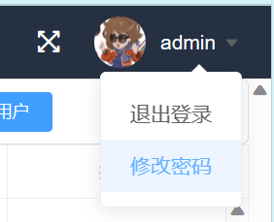

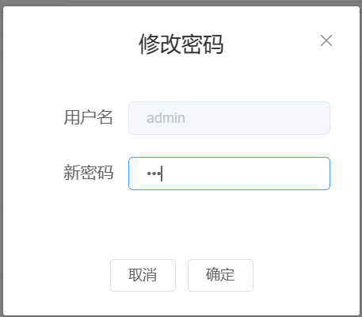

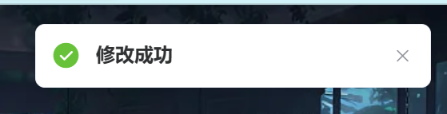

Register for the test:

Steps:

Enter the corresponding information and click Register.

Expected Result:

Registration is successful.

After two seconds, it jumps to the home page.

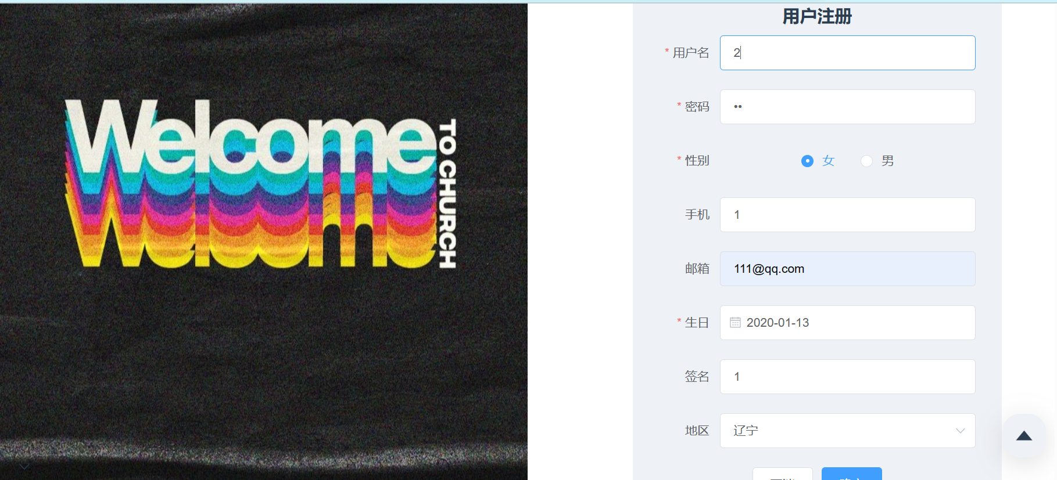

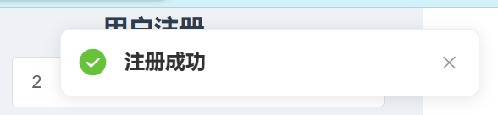

Songs search function test:

Steps:

Enter a keyword in the search box.

Verify that the search results contain the entered keywords.

Click on a song in the search results to verify that it can jump to the corresponding song detail page.

Expected Result:

The search results should contain the entered keywords.

After clicking on a song in the search results, you should be able to successfully jump to the corresponding song details page.

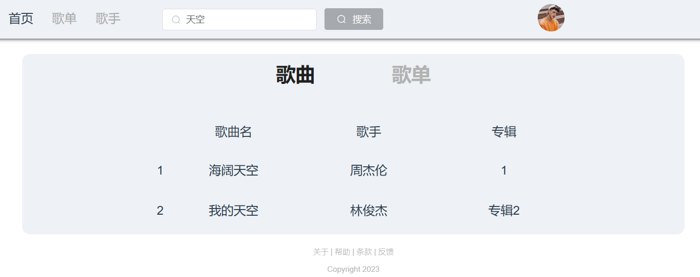

Song list search function test:

Steps:

Enter the keywords in the search box.

Verify that the search results contain the keywords you entered.

Click on a song list in the search results to verify that it can jump to the corresponding song list detail page.

Expected Result:

The search results should contain the entered keywords.

Clicking on a song list in the search results should result in a successful jump to the corresponding song list detail page.

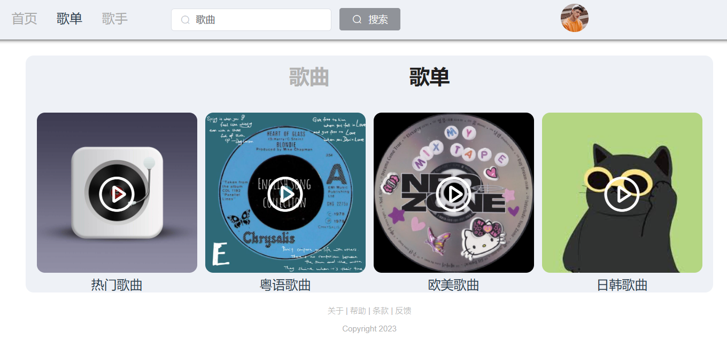

Song detail page test:

Steps:

Open the song details page.

Verify that the information about the song and lyrics are displayed correctly.

Simulate the playback progress and verify that the lyrics are displayed correctly according to the playback progress.

Expected Result:

Information about the song and lyrics should be displayed correctly.

Lyrics should be displayed correctly according to the simulated play progress.

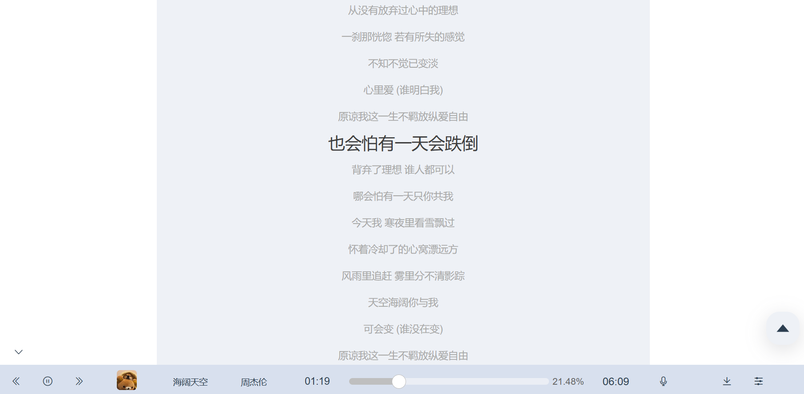

User avatar upload test:

Steps:

Go to the User Settings page.

Click on the Avatar Upload button.

Select an image to upload.

Expected Result:

Avatar upload is successful and the user avatar is displayed as the uploaded image.

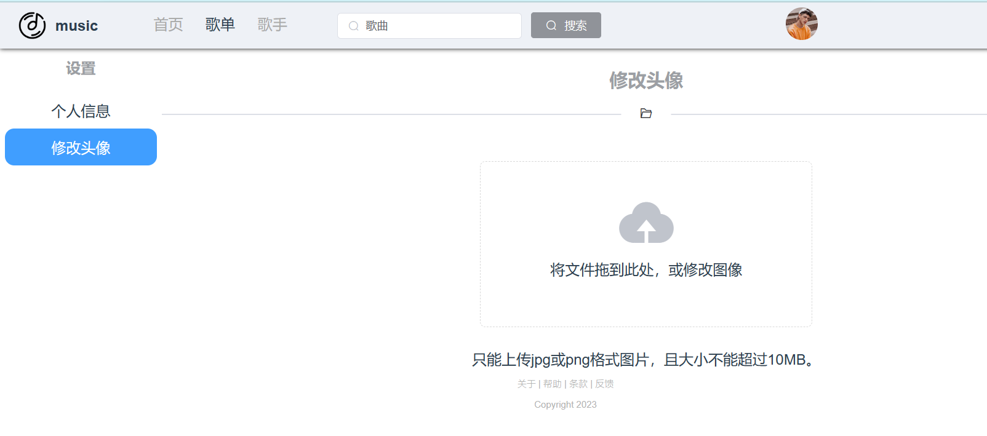

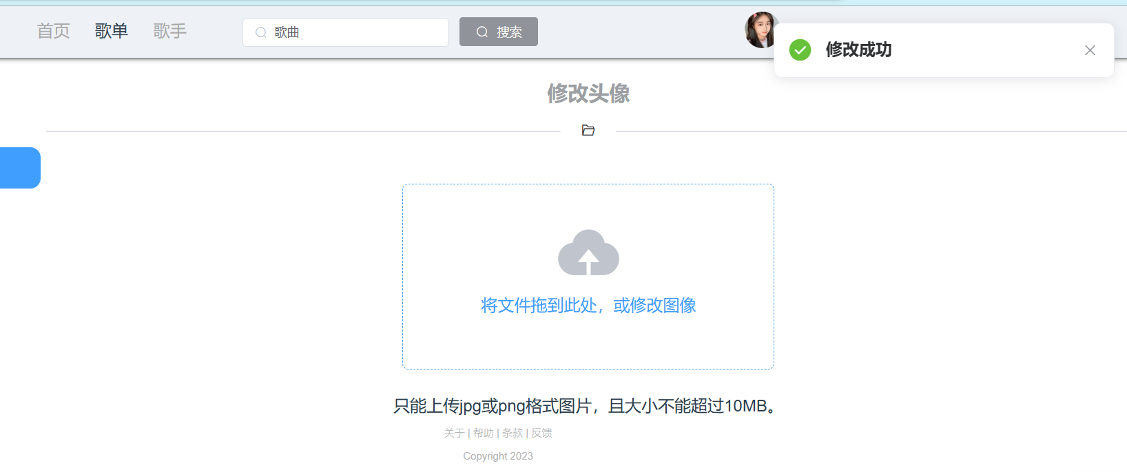

User's personal information edit test:

Step:

Enter the user settings page.

Edit personal information, including user name, gender, age, etc.

Click the Submit button.

Expected Result:

User personal information is successfully updated.

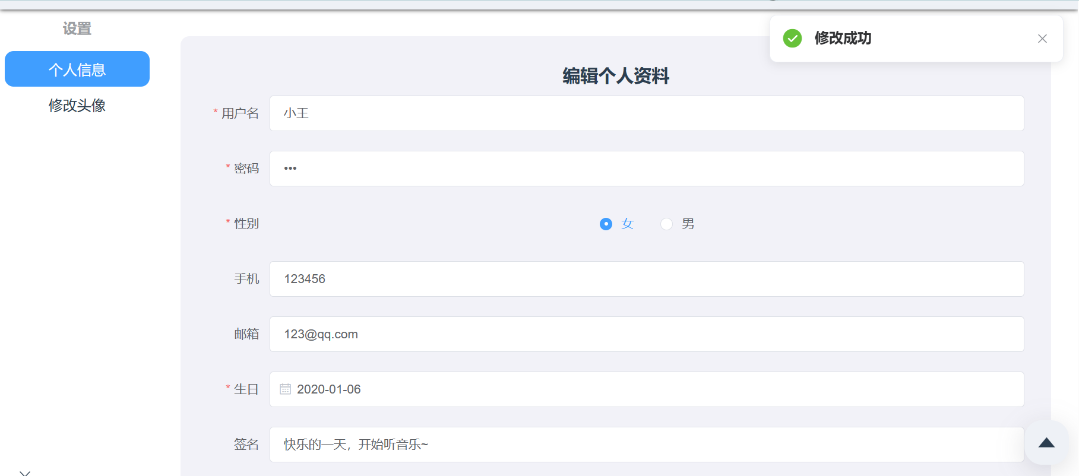

Bottom navigation bar functionality test:

Steps:

Click on different buttons in the bottom navigation bar such as Sound, Playlist, Drag to Progress, Download, Previous, Next, Shrink, etc.

Expected Result:

Clicking on different buttons should result in different functions.

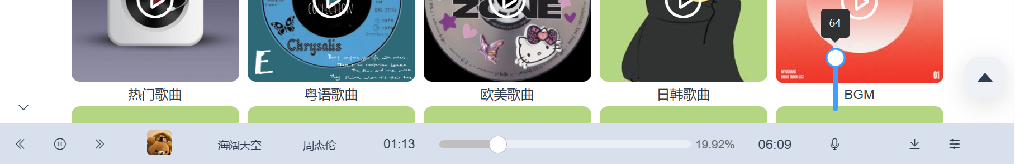

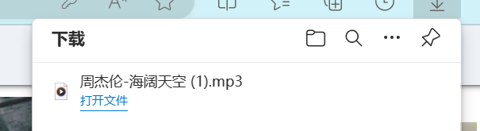

Playlist test:

Steps:

Click on the bottom navigation bar to display the playlist.

Verify that the playlist songs are displayed correctly.

Verify that clicking plays the song.

Expected Result:

Click the bottom navigation bar to display the playlist.

The playlist song is displayed correctly.

Click to play the song.

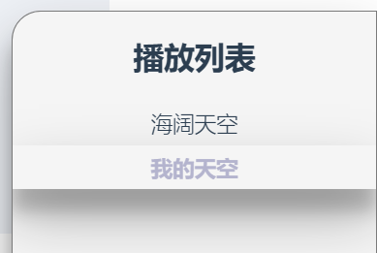

Go back to the top button test:

Steps:

Click on the button.

Expected result:

Back to top.



**4 Summary**

**4.1 Team composition and individual contributions**

|  |  |
| --- | --- |
| team member | Percentage of workload |
| 王素婷 | 100% |

This project was independently produced and completed by王素婷.

**4.2 Project problems and deficiencies**

**User Experience:** The system description lacks details about the user interface and interaction design. It's important to ensure a user-friendly and intuitive interface to enhance the overall user experience.

**Security:** Although the system authorizes and authenticates users, more security measures need to be implemented. Such as strict validation and filtering of user input to prevent common security vulnerabilities such as cross-site scripting (XSS) and SQL injection attacks.

**Error handling:** The system simply outputs errors and exceptions without really handling them. Appropriate error handling mechanisms should be in place to provide meaningful error messages and handle exceptions gracefully.

**Performance and scalability:** The system does not mention performance optimization or scalability considerations. As the number of users grows and the system processes more data, it is important to ensure that the system can handle the increased load and maintain acceptable performance levels.

**Internationalization and localization:** The system does not address multilingual support. If the system is intended for a global audience, localization should be supported to accommodate users in different regions and languages.

**4.3 Project outlook**

**Improvement of user experience:** Enhance the overall user experience in the system by optimizing the interface design, improving the page loading speed and response performance, and improving the search algorithm and recommendation system to make it more smooth, intuitive and personalized.

**Enhancement of Social Interaction Functions:** Introduce more social interaction functions in the system, such as following, commenting and sharing among users, in order to promote interactions and exchanges among users, and enhance user stickiness and community activity.

**User personalized recommendation:** Based on users' historical behaviors, preferences and interests, a personalized recommendation system is constructed to provide users with more accurate and personalized recommendations of songs and song lists, in order to enhance user satisfaction and retention.

**Enhancement of security and privacy protection:** Enhance the security of the system, including user authentication, encryption of sensitive data, vulnerability repair, and security auditing, in order to protect the security and privacy of user data.

**Multi-platform adaptation and mobile applications:** Adapt the system to different platforms, such as mobile devices and tablets, to provide a wider range of access channels. At the same time, mobile applications are developed to provide a more convenient music playback and management experience.

**Continuous system optimization and technical upgrades:** Through continuous system optimization and technical upgrades, improve the performance, stability and scalability of the system to cope with the demands of user scale and functional growth.

**5 Learning Experience**

**5.1 Technical experiences**

**Vue.js:** Learned how to build front-end user interfaces using Vue.js, a popular JavaScript framework that provides componentized development and responsive data binding, making front-end development more efficient and flexible.

Element UI: Learned how to use Element UI to build user interfaces that provide a great user experience.

**ECharts:** Learn how to use ECharts to display and analyze the data in the system, providing intuitive data display and analysis functions.

**Spring Boot:**

Build Applications Quickly: Spring Boot provides a quick way to build applications, which helps simplify the process of initializing and configuring projects through auto-configuration and default conventions. After learning Spring Boot, you will find it easier and more efficient to create a basic application.

Simplified Dependency Management: Spring Boot simplifies dependency management for projects by providing a collection of available Starter Dependencies. These starter dependencies are preconfigured with commonly used libraries and frameworks, so you can simply select the desired starter dependencies and the associated dependencies will be automatically introduced, reducing the effort of manual configuration.

Automated Configuration: Based on the principle of convention over configuration, Spring Boot provides default configuration for applications through an automated configuration mechanism. After learning Spring Boot, you will learn how to use auto-configuration to reduce sample code, simplify configuration files and improve development efficiency.

**Spring MVC:** Spring MVC is a module in the Spring Framework for building web applications based on the MVC pattern. Learned how to use Spring MVC to handle user requests, manage routes and controllers, and pass data to the front-end interface.

**MyBatis:**

Object-Relational Mapping (ORM): After learning MyBatis, learn how to define mapping relationships between objects and database tables through configuration and mapping files, making database operations easier and more concise.

Flexible SQL Mapping: MyBatis provides flexible SQL mapping methods, you can use XML files or annotations to define SQL statements, including query, insert, update and delete operations. After learning MyBatis, learn how to write and manage SQL statements and how to use dynamic SQL and parameter mapping to handle different query conditions and database operations.

**MySQL:** Learn how to use MySQL for database design and management, including table creation, data manipulation and query statement writing.

**Redis:** Redis is a high-performance key-value store database, learnt how to use Redis to store and manage cached data in the system, improve system performance and response speed.

**JWT:** JWT (JSON Web Token) is an open standard for authentication and authorisation. Learned how to use JWT to implement user authentication and authorisation functions to protect the security of the system.

**5.2 Learning experiences**

**Practical project experience:** I gained valuable practical project experience by completing this project. Participate in a complete project development process from start to finish, including various stages such as requirement analysis, technology selection, system design, coding implementation and testing. This will help me to understand the whole process of software development and gain the ability to solve real-world problems.

**Deeper understanding of technologies:** By practically applying the technology stack in this project, I gain a deeper understanding of how these technologies work and how they are used. Will learn how to combine different technologies to solve real problems and understand the collaboration and interaction between technologies. This will give me a deeper understanding and mastery of these technologies and provide a solid foundation for future project development.

**Self-learning and problem-solving skills:** In the course of completing this project, I have encountered various technical challenges and problems. My problem-solving ability will be honed and enhanced as I take the initiative to seek solutions, engage in self-learning and exploration. This is very important for my future study and career development.